PCK-CNC

Assembly instructions

Rev. A

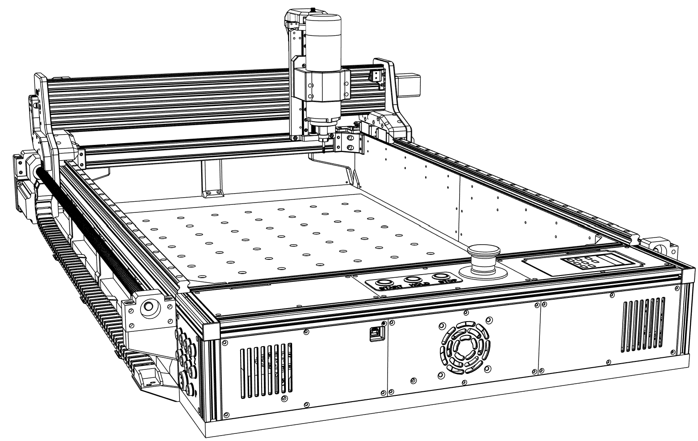

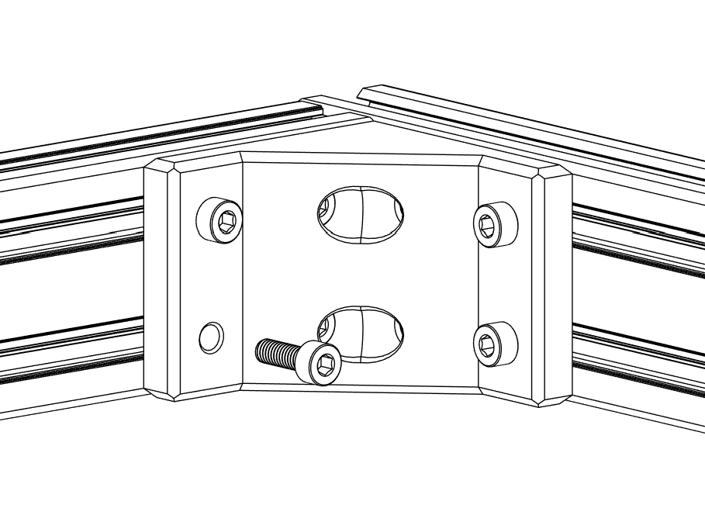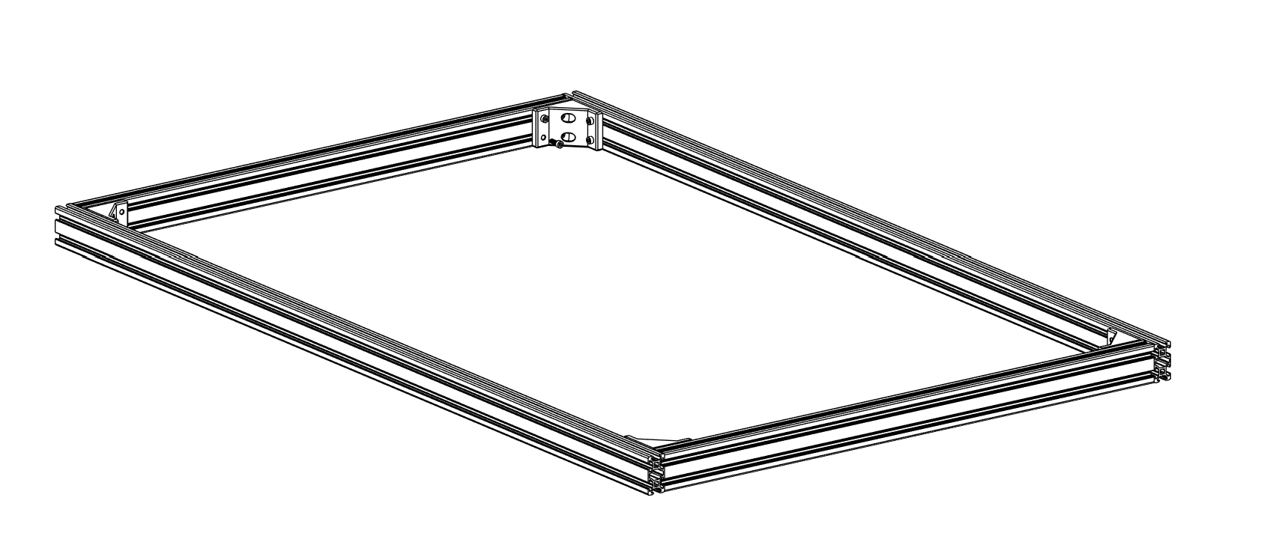

① Connect **2040 aluminum profiles** with **Frame corner connectors**, M4x12mm screws and M4 T-slot nuts.

② Make sure the frame is perfectly squared.

2 x 2040 Aluminum profile 600 mm

2 x 2040 Aluminum profile 1000 mm

4 x Frame corner connector

16 x M4x12 mm (Socket head)

16 x M4 T-slot nut

## Frame assembly

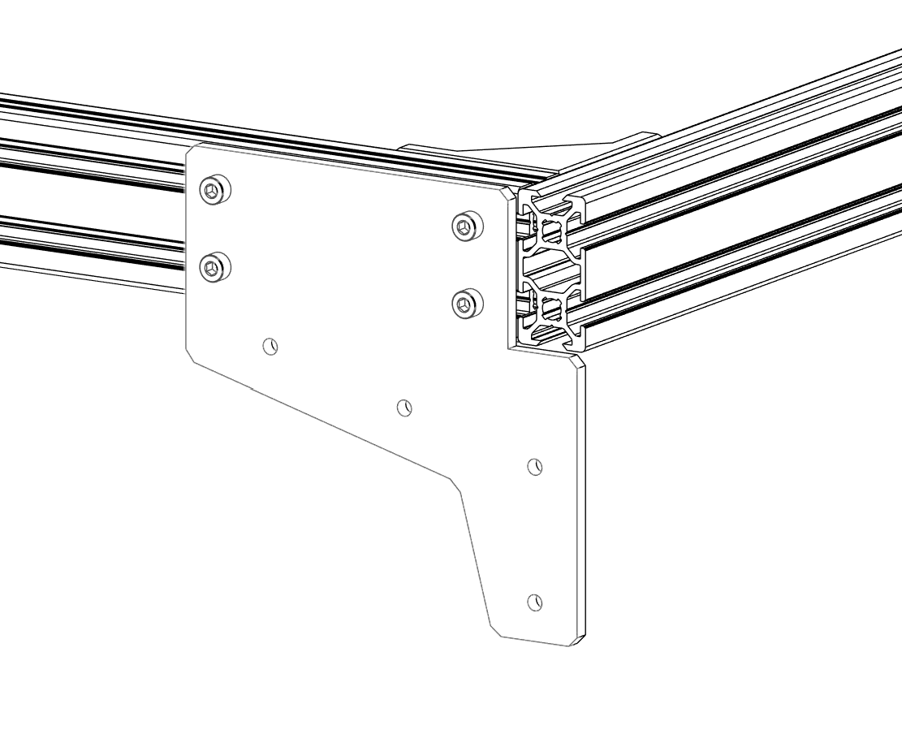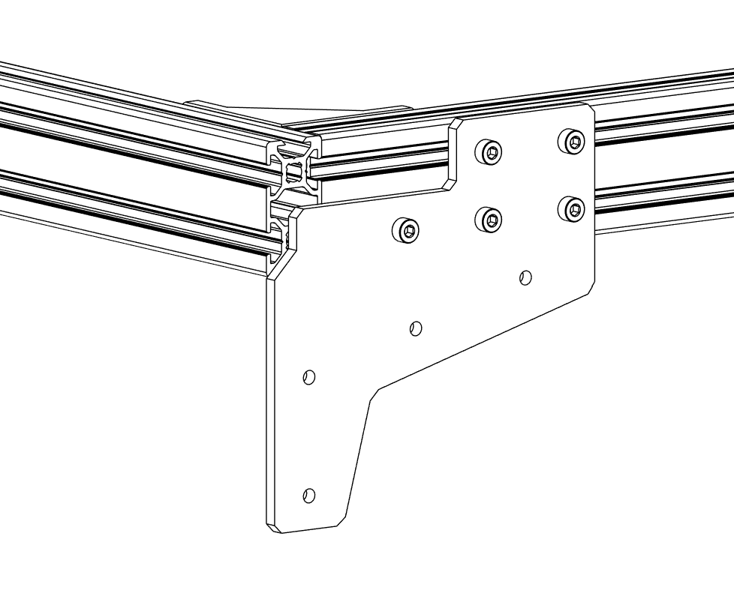

① Attach aluminum **Base mounts (FRONT, REAR)** with M4x8mm screws and M4 T-slot nuts.

Rear

Front

2 x Base mount FRONT (Aluminum)

2 x Base mount REAR (Aluminum)

18 x M4x8 mm (Socket head)

18 x T-slot nut

## Frame assembly

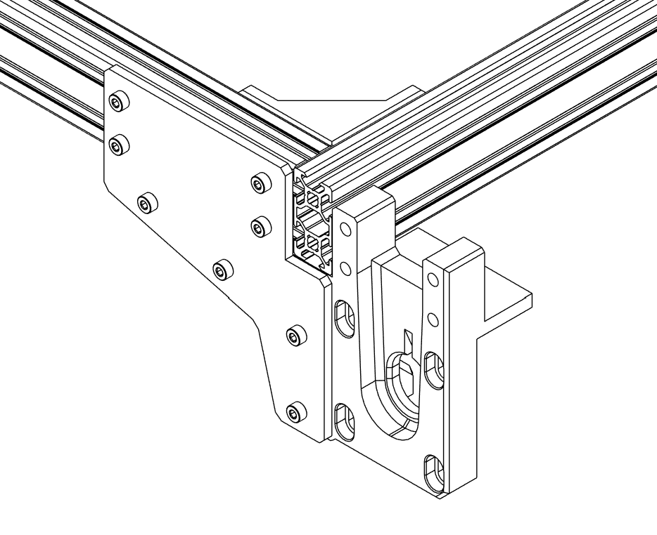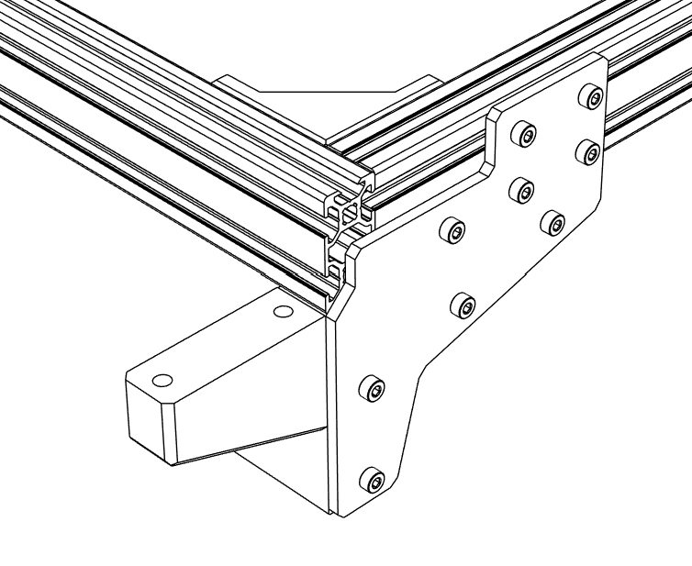

① Install **Y Axis motor mounts** (Rear) with M4x16mm screws.

② Install **Base mounts** (Front) with M4x16mm screws.

1 x Base mount FRONT R

1 x Base mount FRONT L

1 x Y Axis motor mount R

1 x Y Axis motor mount L

16 x M4x16 mm (Socket head)

aaaaaaaaaa dddw

tat

waaaaa ddd

Front

Rear

## Frame assembly

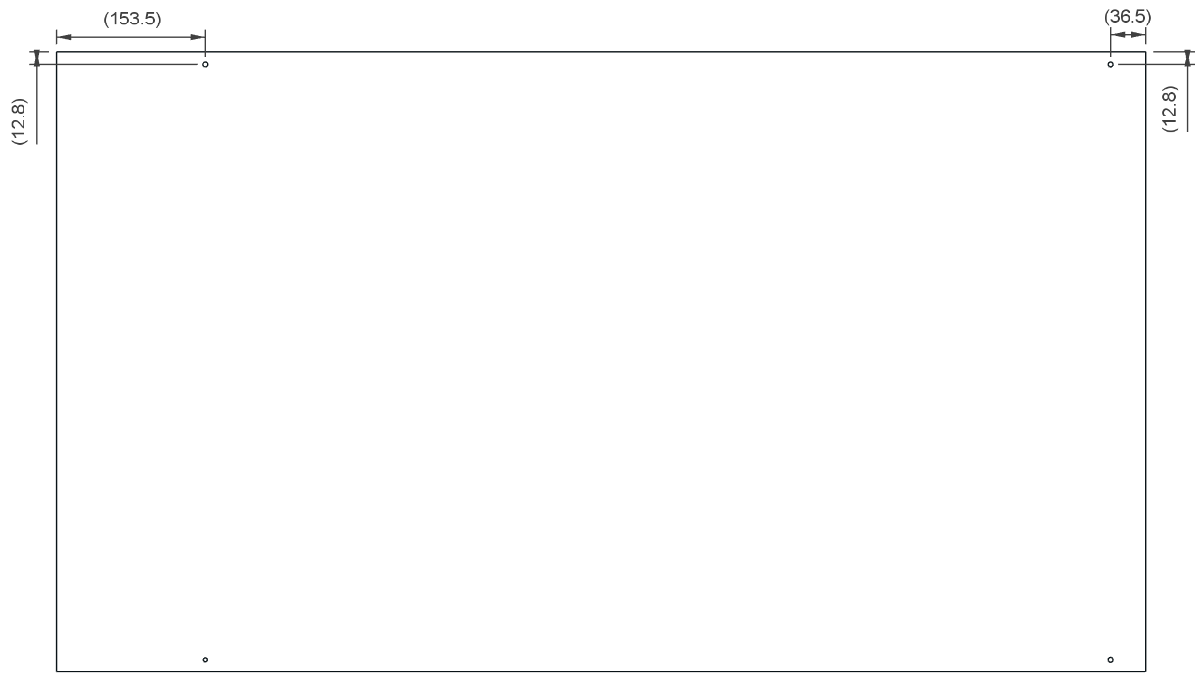

1 x Base board (MDF 20 mm)

① Drill out four 5mm holes according to the drawing.

② Countersink holes on the bottom side with 10mm drill bit at least 5.5 mm deep.

## Frame assembly

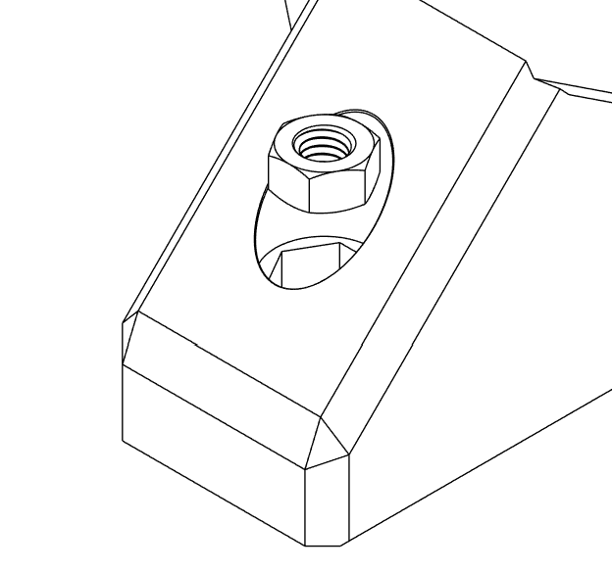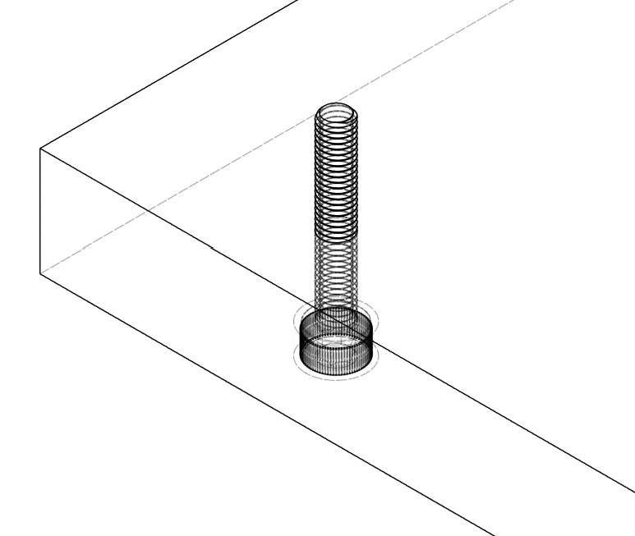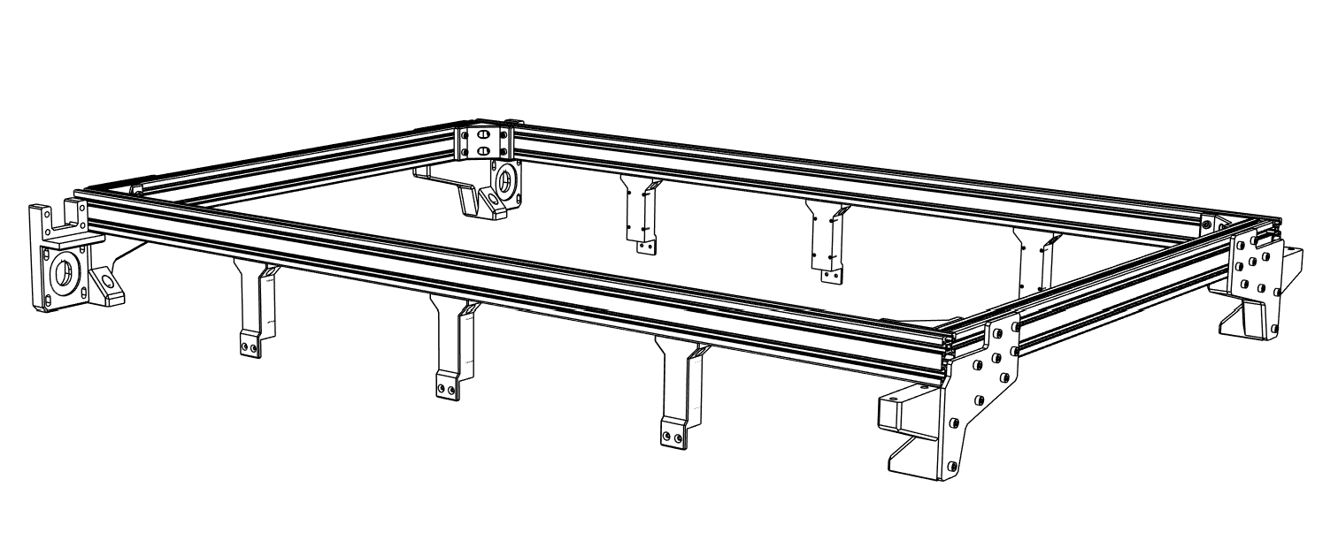

4 x M5x30 mm

4 x M5 Nut

① Insert M5x30 mm screws into all four corners of the **Base board**.

② Insert M5 Nuts into Base mounts (Front) and Y Axis motor mounts (Rear).

## Frame assembly

6 x Base support

12 x M3x10 mm

12 x M3 T-slot nut

① Install all six **Base supports** with M3x10 mm screws and M3 T-slot nuts.

## Frame assembly

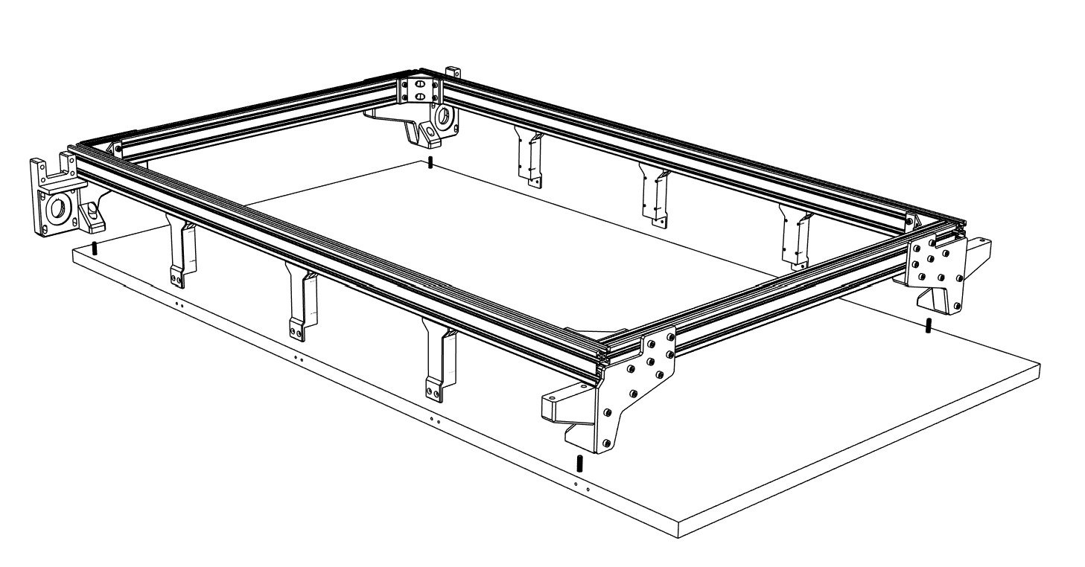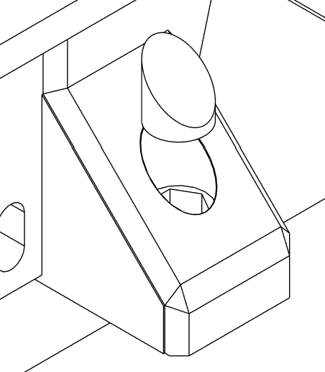

① Connect the frame and Base board with the screws installed in previous step.

② Secure Base supports with 3x20mm screws into the Base board.

③ Cover the nuts with **Nut caps.**

4 x Nut cap

12 x 3x20mm wood screw (Flat head)

## Frame assembly

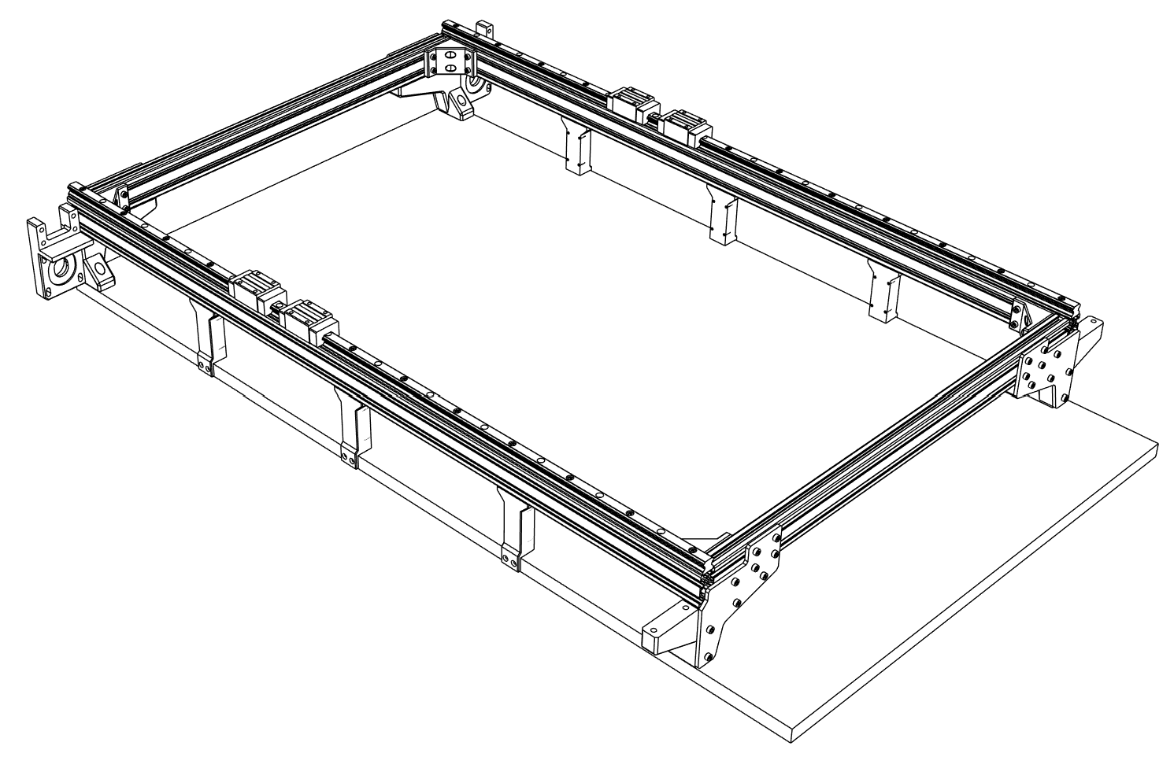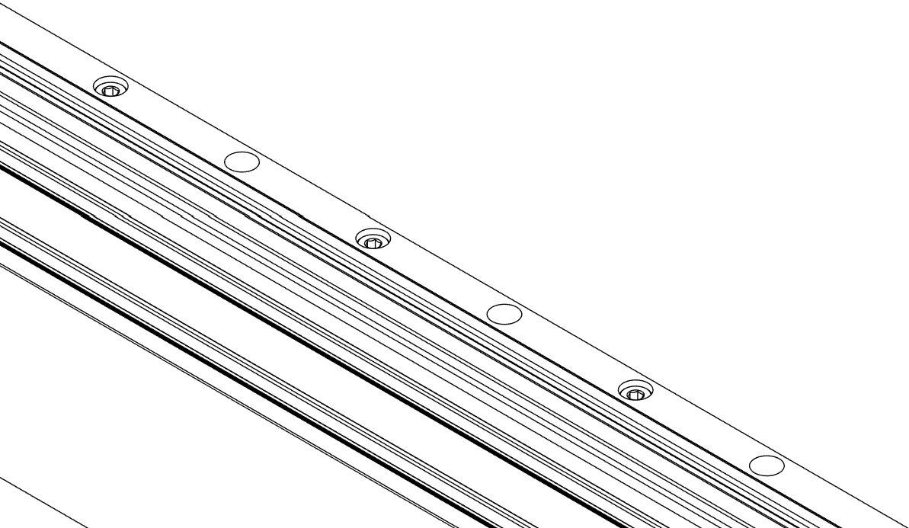

① Install two **HGR15 linear rails** using M4x12 mm screws and M4 T-slot nuts.

② Slide two **HGH15CA linear rail blocks** on each rail and fix them in place (temporary).

2 x Linear rail HGR15 (1000mm)

4 x Linear rail block HGH15CA

26 x M4x12 mm (Socket head)

26 x M4 T-slot nut

## Frame assembly

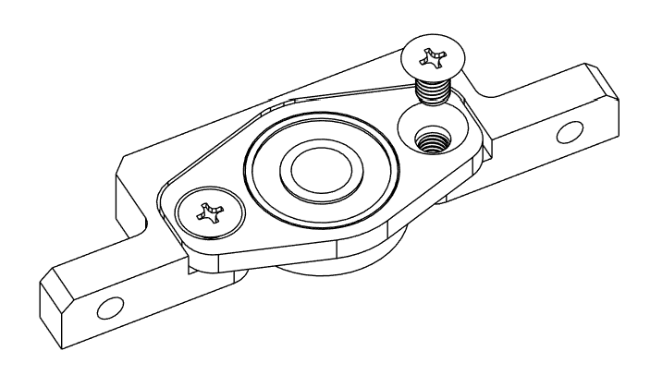

① Secure the **KFL08 leadscrew housing** to **Z Axis leadscrew bearing mount** with M5x8 mm screws.

1 x Z Axis leadscrew bearing mount

1 x Leadscrew housing KFL08 8mm

2 x M5x8 mm (Flat head)

## Z Axis assembly

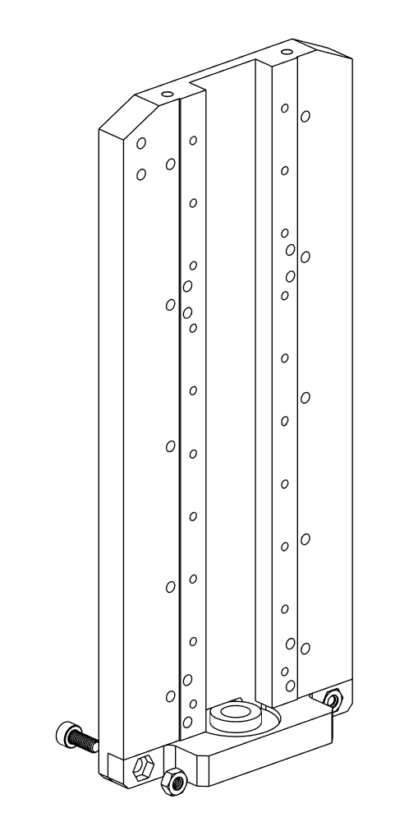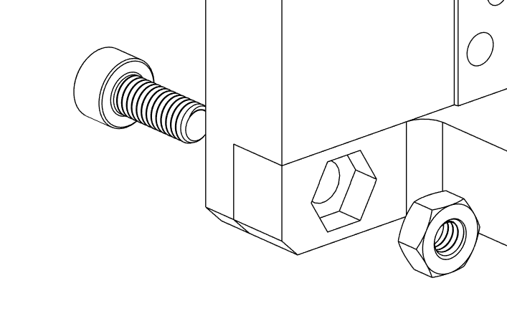

① Secure the Z Axis leadscrew bearing mount to **Z Axis plate** withM4x10 mm screws and M4 nuts.

1 x Z Axis plate (Aluminum)

2 x M4x10 mm (Socket head)

2 x M4 Nut

## Z Axis assembly

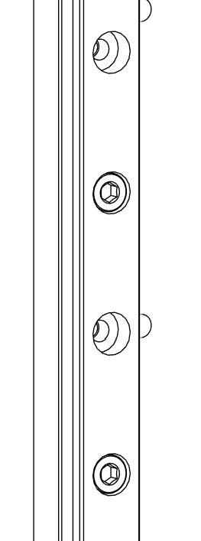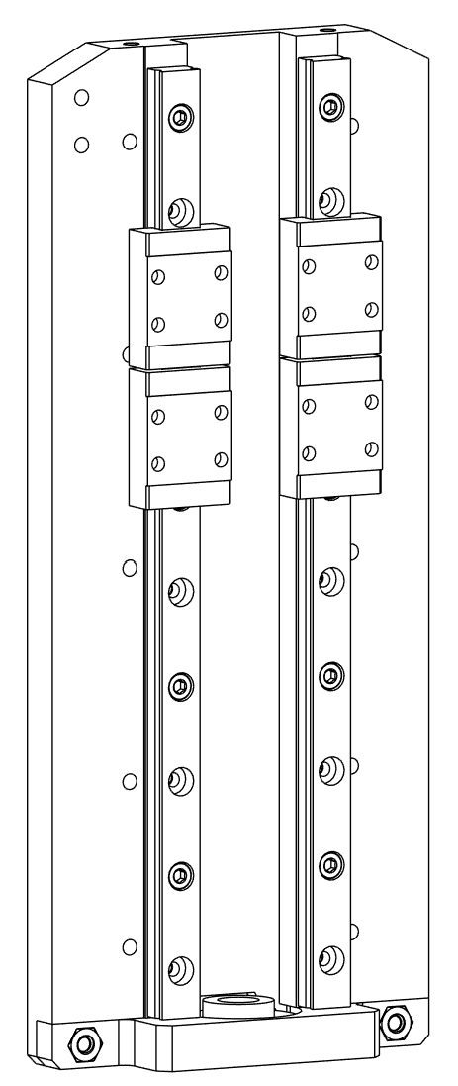

① Install two **MGN9 linear rails** with M3x10 mm screws.

② Slide two **MGN9C linear rail blocks** on each linear rail.

2 x Linear rail MGN9 (200mm)

4 x Linear rail block MGN9C

10 x M3x10 mm (Socket head)

## Z Axis assembly

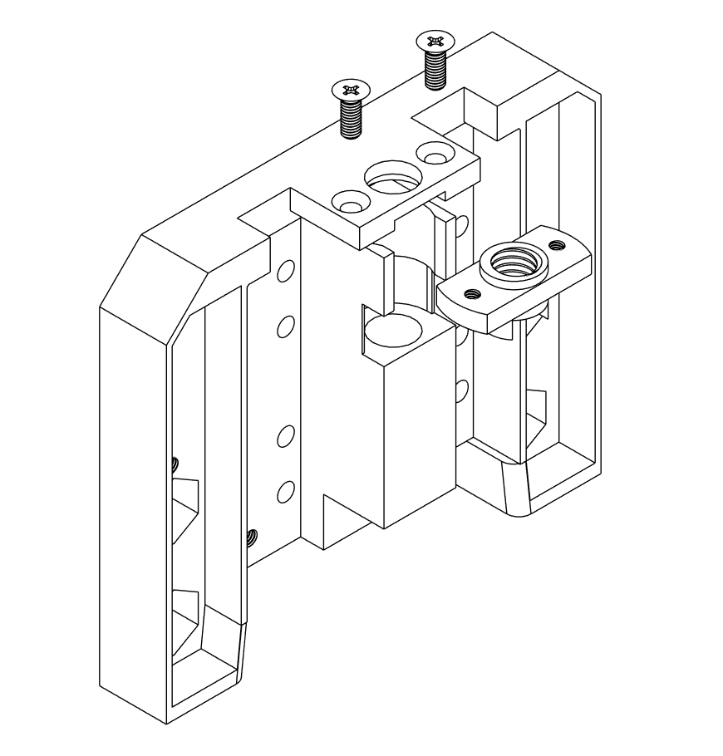

① Insert the **Leadscrew nut** into **Z Axis linear rails mount** and attach it with M3x8 mm screws.

1 x Z Axis linear rails mount

1 x Leadscrew nut (M8)

2 x M3x8 mm (Flat head)

## Z Axis assembly

## 

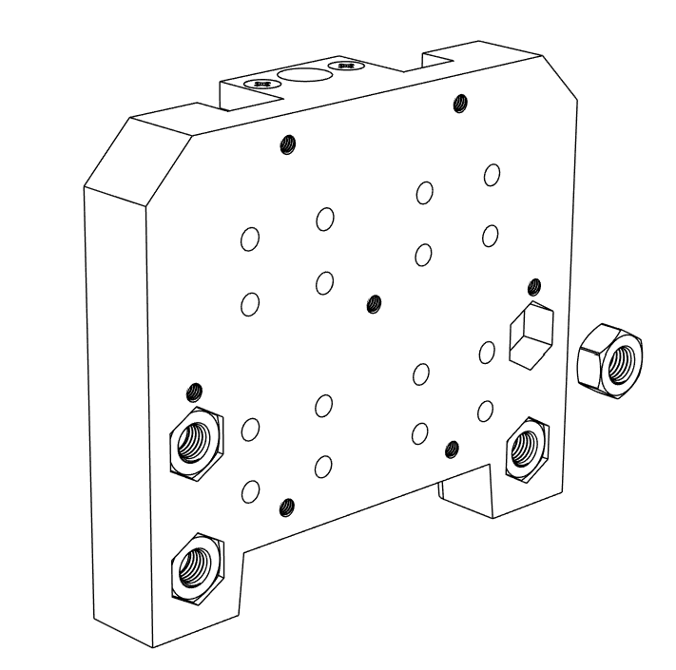

① Insert M6 nuts into the Z Axis linear rails mount.

② If the fit is too loose secure it with some glue.

4 x M6 Nut

## Z Axis assembly

## 

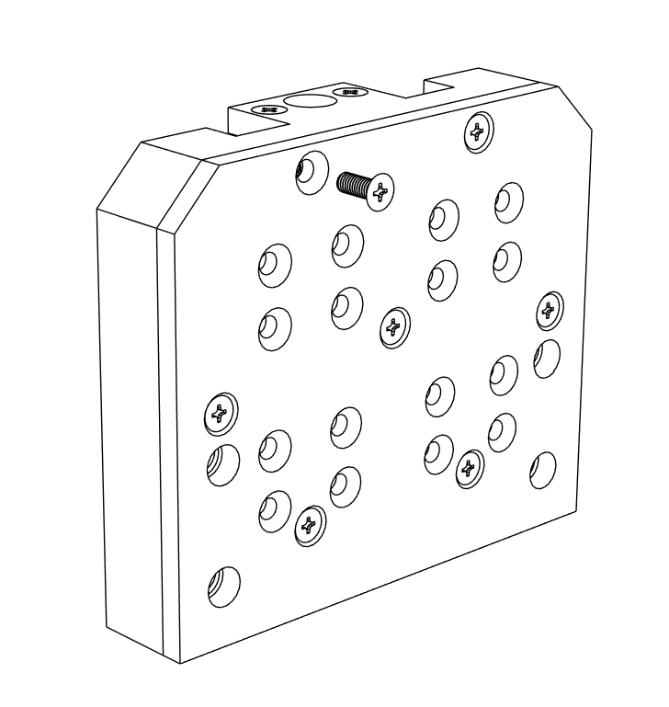

1 x Spindle mount plate (Aluminum)

7 x M3x8 mm (Flat head)

① Install **Spindle mount plate** with M3x8 mm screws.

## Z Axis assembly

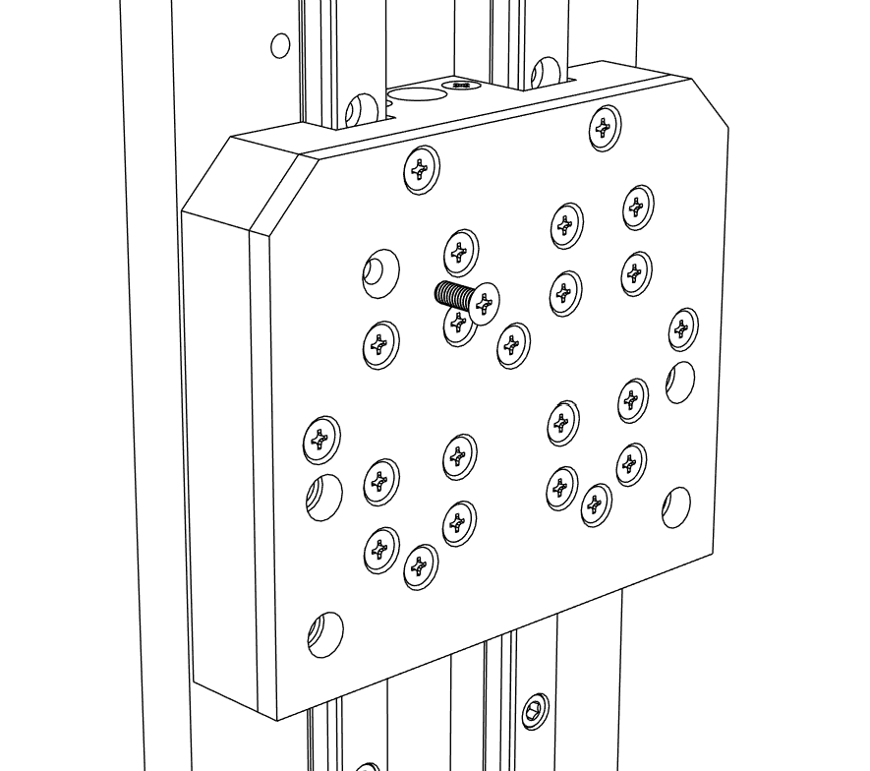

① Attach the assembled spindle mount to the linear rail blocks with M3x8 mm screws.

16 x M3x8 mm (Flat head)

## Z Axis assembly

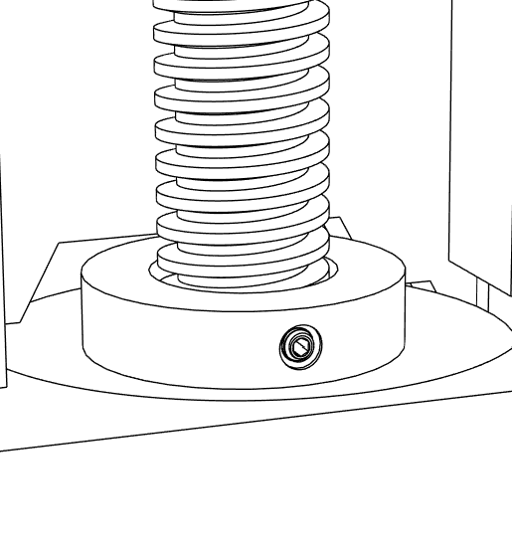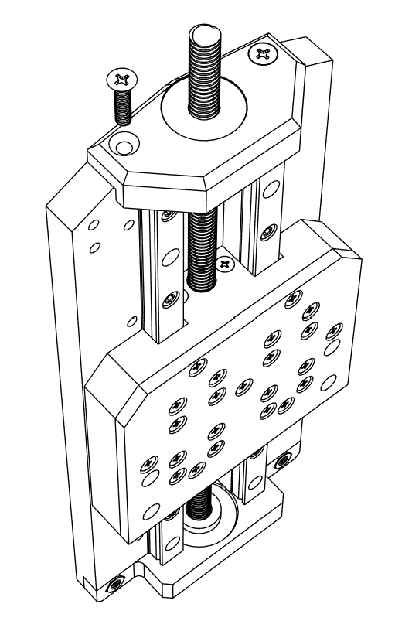

③

① Insert **608ZZ bearing** into the **Z Axis leadscrew bearing mount TOP.**

② Attach the Z Axis leadscrew bearing mount TOP to Z Axis plate with M4x16 mm screws.

③ Screw in the **T8** **Leadscrew** and secure it in the leadscrew housing with a set screw.

1 x Z Axis leadscrew bearing mount TOP

1 x 608ZZ Bearing

1 x T8 Leadscrew - 2mm lead (200 mm)

2 x M4x16 mm (Flat head)

## Z Axis assembly

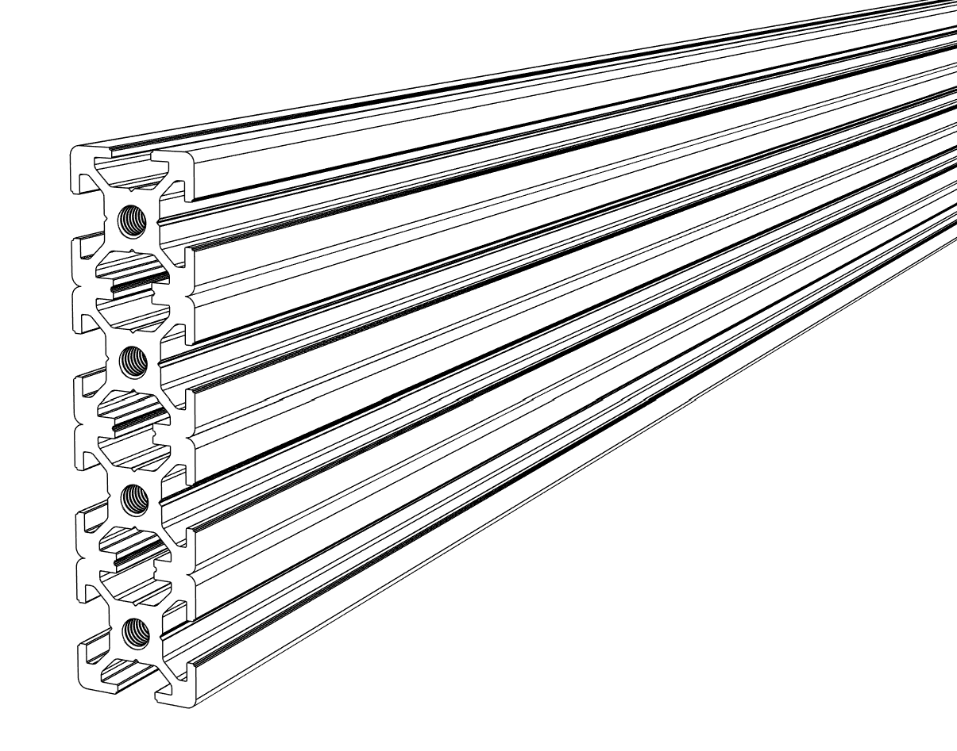

① Tap four M5 threads on each side of the **2080 aluminum profile**.

② Make the threads at least 16 mm deep.

1 x Aluminum profile 20x80 mm (670 mm)

## X Axis assembly

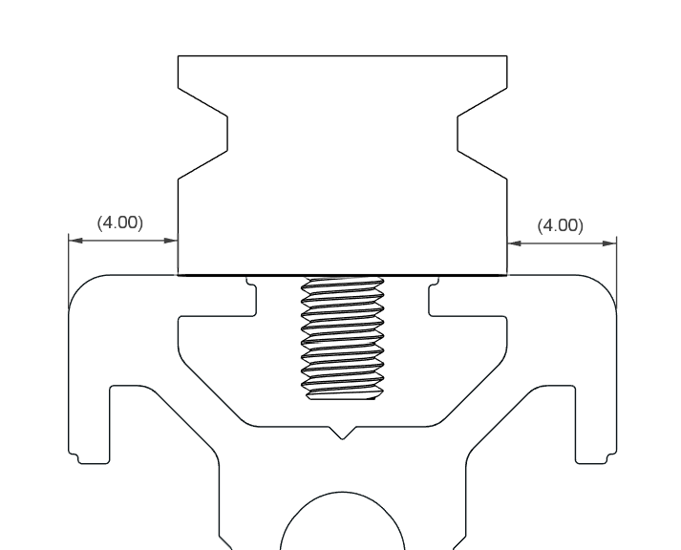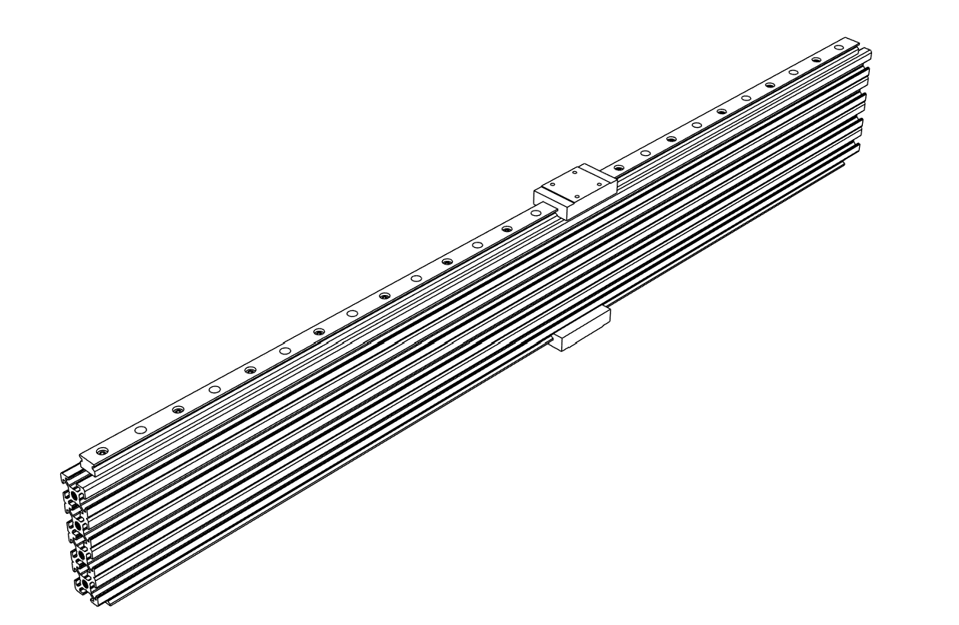

① Install two **MGN12 linear rails** on 2080 aluminum profile with M3x8 mm screws and M3 T-slot nuts.

② Make sure that both rails are perfectly centered as shown in the detailed picture.

③ Slide on **MGN12H linear rail blocks**, one on each rail.

②

2 x Linear rail MGN12 (650 mm)

2 x Linear rail block MGN12H

26 x M3x8 mm (Socket head)

26 x M3 T-slot nut

## X Axis assembly

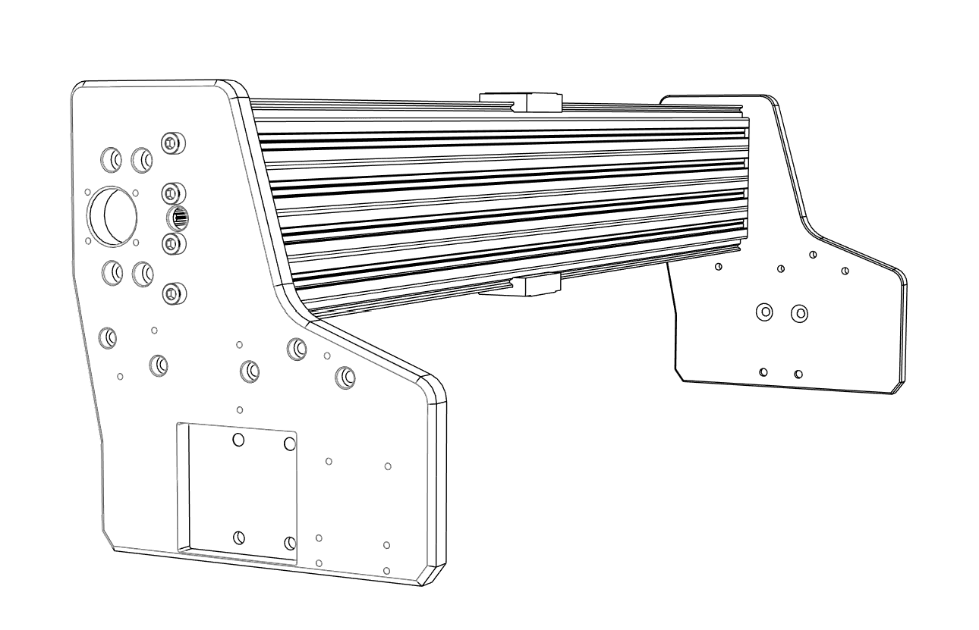

① Install **X Axis plate LEFT** with M5x20 mm screws.

② Temporarily attach **X Axis plate RIGHT** with M5x20 mm screws. Screws will be replaced later by M5x25 mm when installing motor mount.

1 x X Axis plate RIGHT (Aluminum)

1 x X Axis plate LEFT (Aluminum)

4 x M5x20 mm (Socket head)

4 x M5x20 mm (Socket head) – Temporary

## X Axis assembly

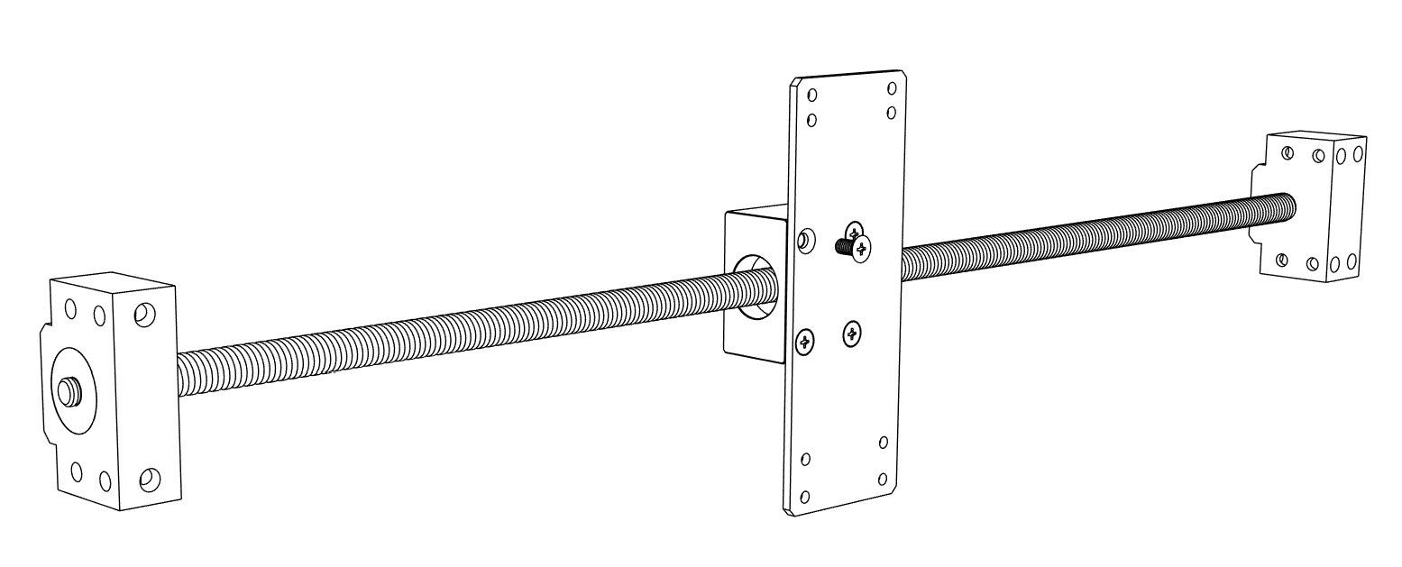

① Assemble the **SFU1204 ballscrew** with all its components.

② Secure **Z Axis back plate** to the **DSG12H ball nut housing** with M5x10 mm screws.

1 x Z Axis back plate

1 x Ballscrew SFU1204 - 650mm

1 x Ball nut housing DSG12H

1 x Ballscrew housing BK10

1 x Ballscrew housing BF10

4 x M5x10 mm (Flat head)

## X Axis assembly

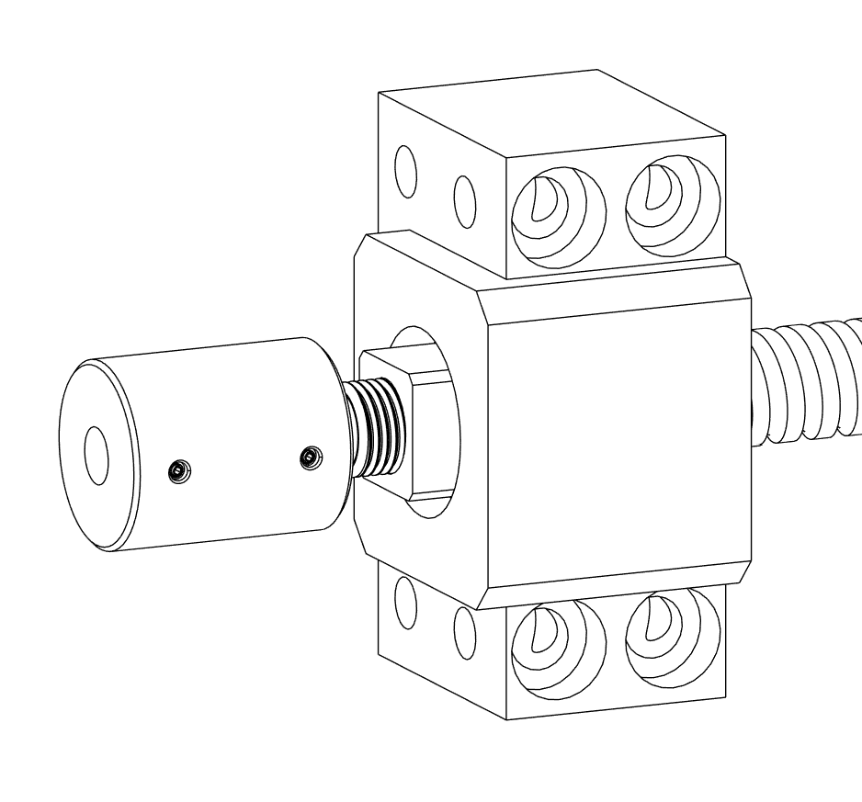

① Install **Motor coupler D19xL25** on the ball screw with its set screws.

1 x Motor coupler D19xL25

## X Axis assembly

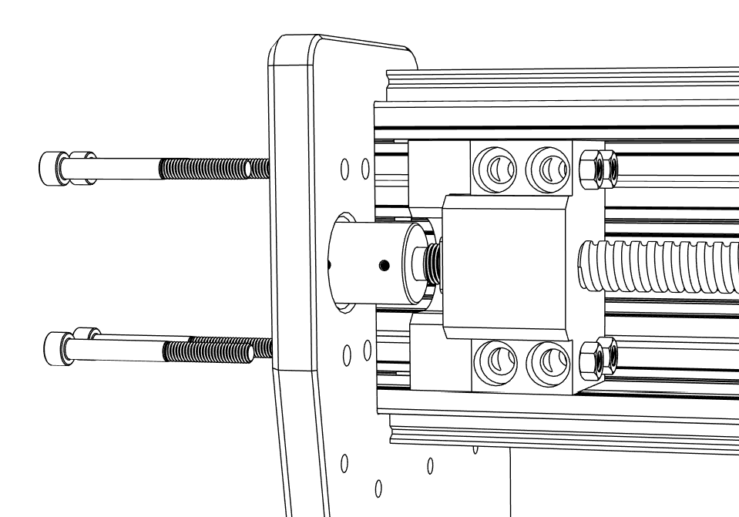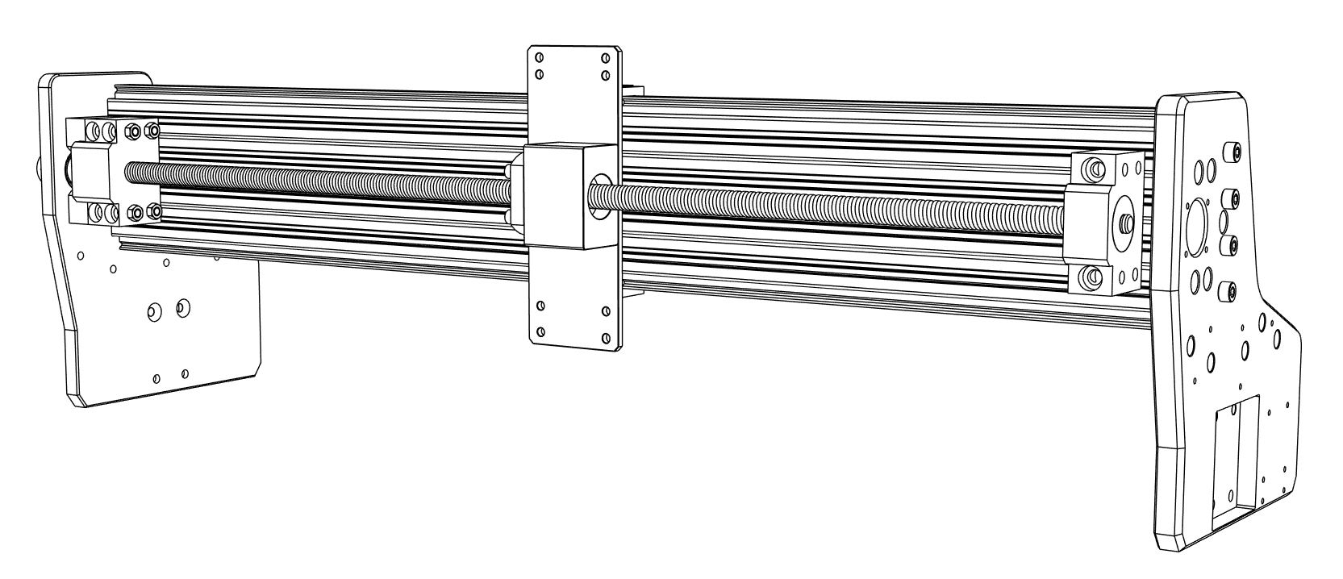

1 x X Axis ballscrew mount RIGHT

4 x M5x50 mm (Socket head)

4 x M5 Nut

① Slide in the motor coupler through the X Axis plate RIGHT.

② Secure the **X Axis ballscrew mount RIGHT** and ball screw housing with M5x50 mm screws.

## X Axis assembly

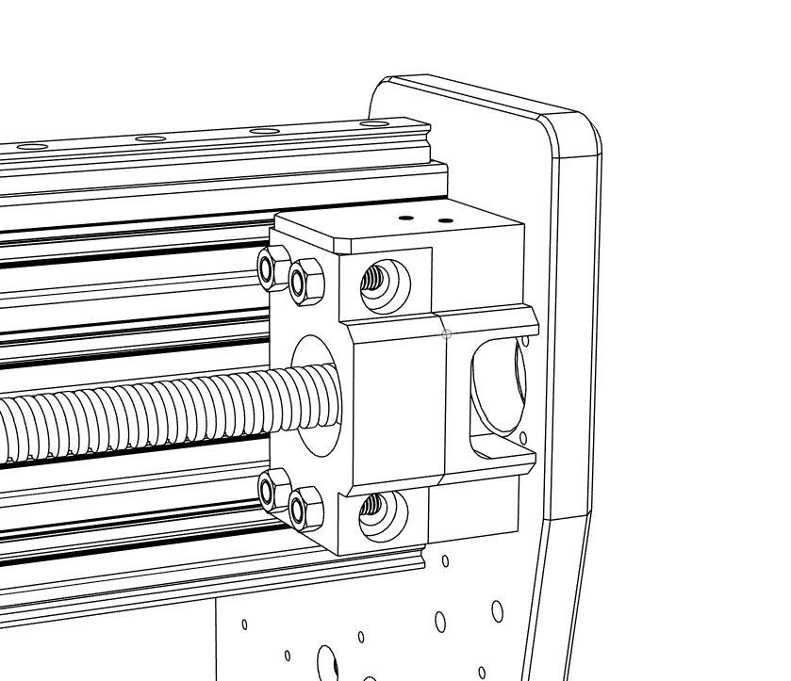

① Install the **X Axis ballscrew mount LEFT** with M5x50 mm screws and M5 nuts.

1 x X Axis ballscrew mount LEFT

4 x M5x50 mm (Socket head)

4 x M5 Nut

## X Axis assembly

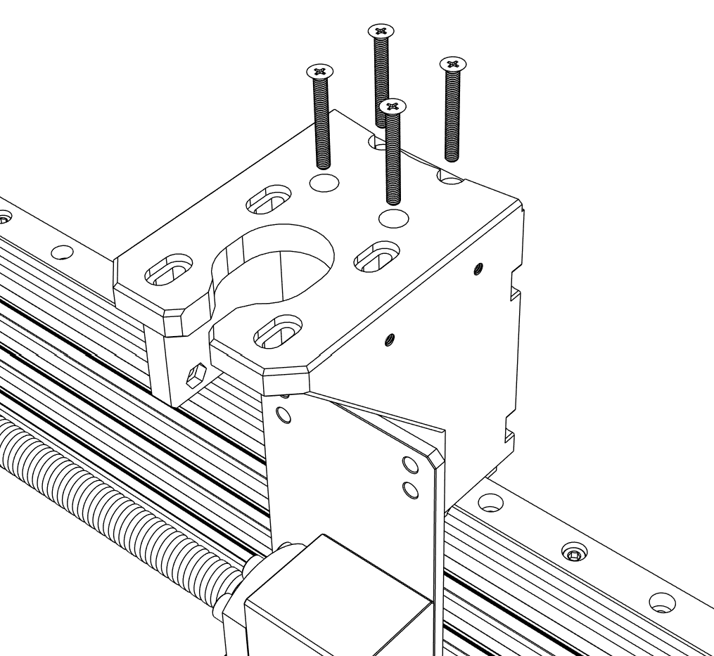

① Attach **Z Axis motor mount** to the top side X axis linear rail block with M3x20 mm screws.

1 x Z Axis motor mount

4 x M3x25 mm (Flat head)

## X Axis assembly

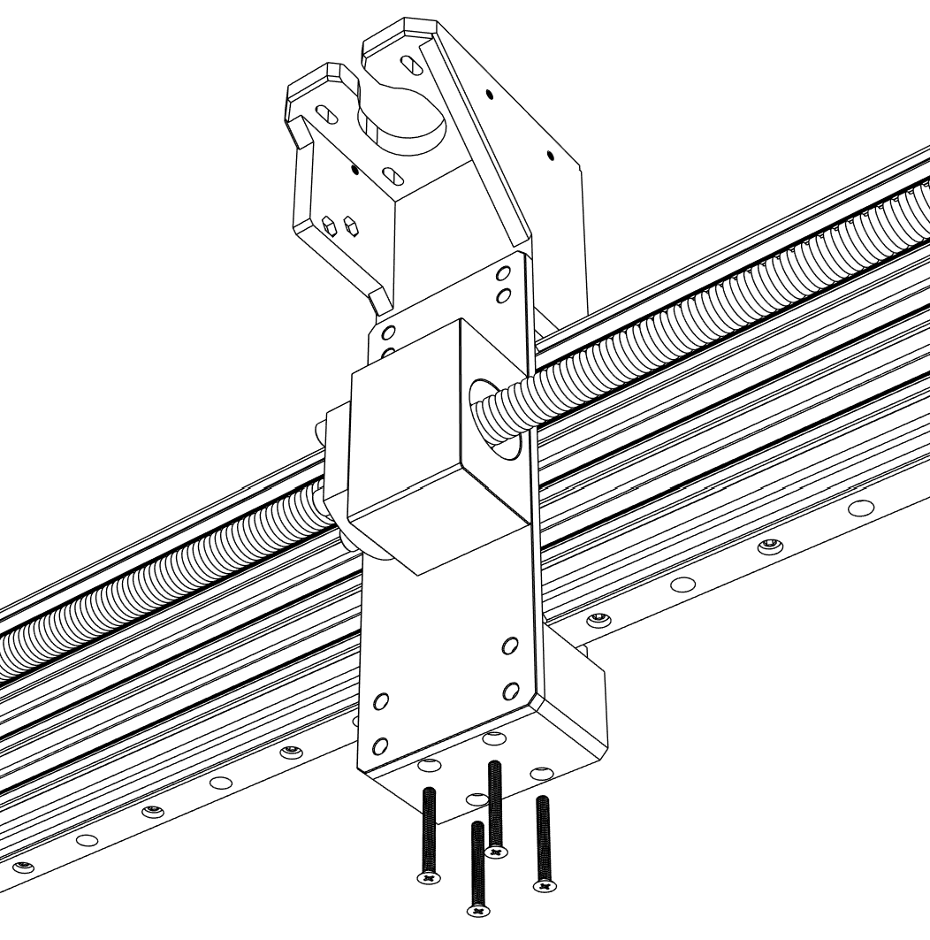

① Attach **Z Axis linear rail mount** to the bottom side X axis linear rail block with M3x20 mm screws.

1 x X Axis linear rail mount

4 x M3x25 mm (Flat head)

## X Axis assembly

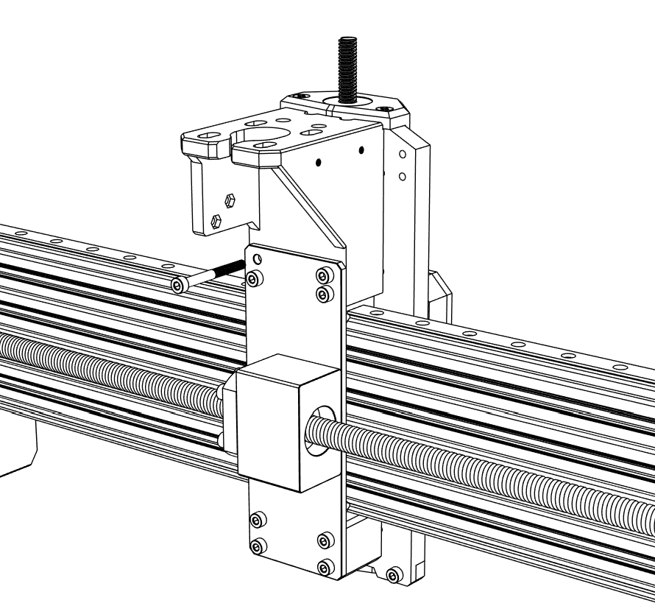

8 x M4x40 mm (Socket head)

2 x M3 Nut

① Connect previously assembled Z Axis to the X Axis assembly with M4x40 mm screws.

## X & Z Axis assembly

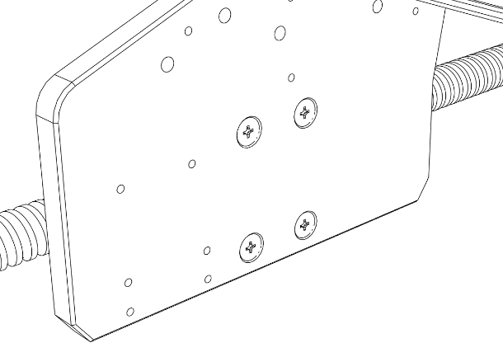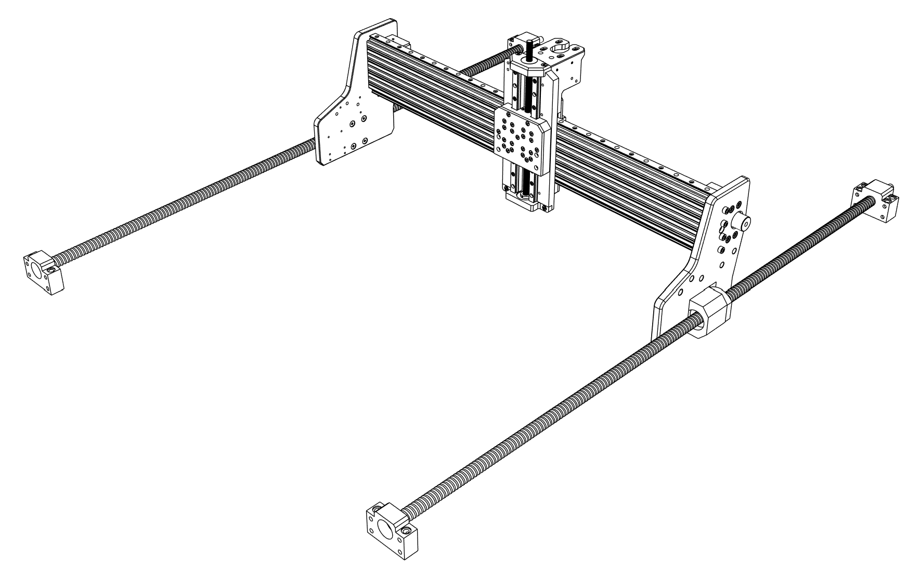

① Assemble the **SFU1605 ballscrew** with all its components.

② Install ballscrews to the X Axis plates on both side with M5x10 mm screws.

2 x Ballscrew SFU1605 - 1000mm

2 x Ball nut housing DSG16H

2 x Ballscrew housing BK12

2 x Ballscrew housing BF12

8 x M5x10 mm (Flat head)

## Y Axis assembly

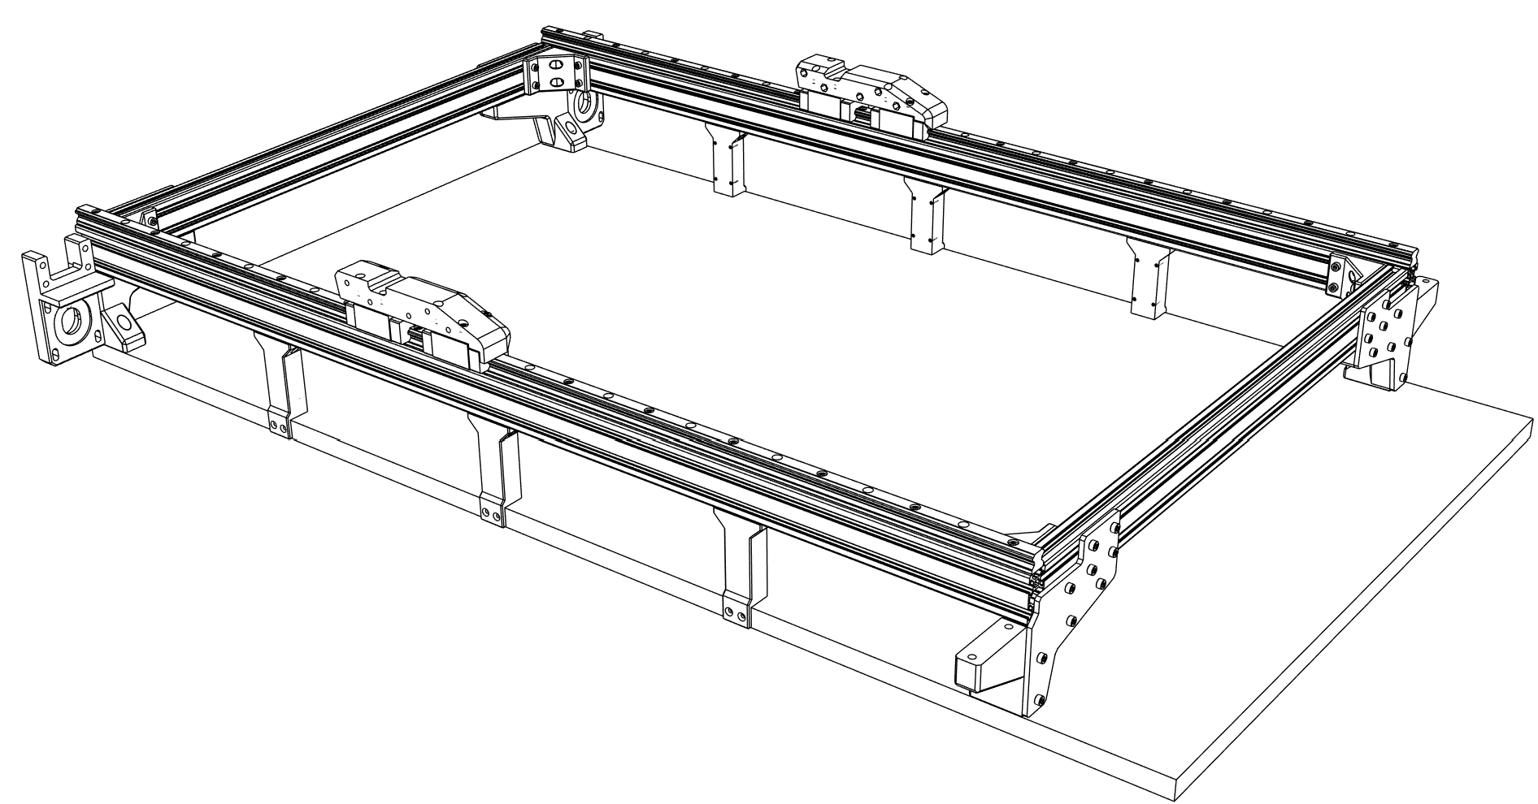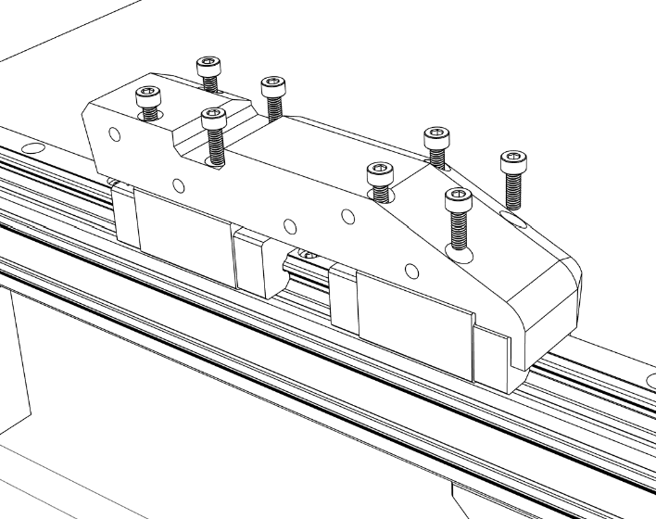

① Install **Y Axis linear rail mounts** on both sides with M4x12 mm screws.

1 x Y Axis linear rail mount RIGHT

1 x Y Axis linear rail mount LEFT

16 x M4x12 mm (Socket head)

## Y Axis assembly

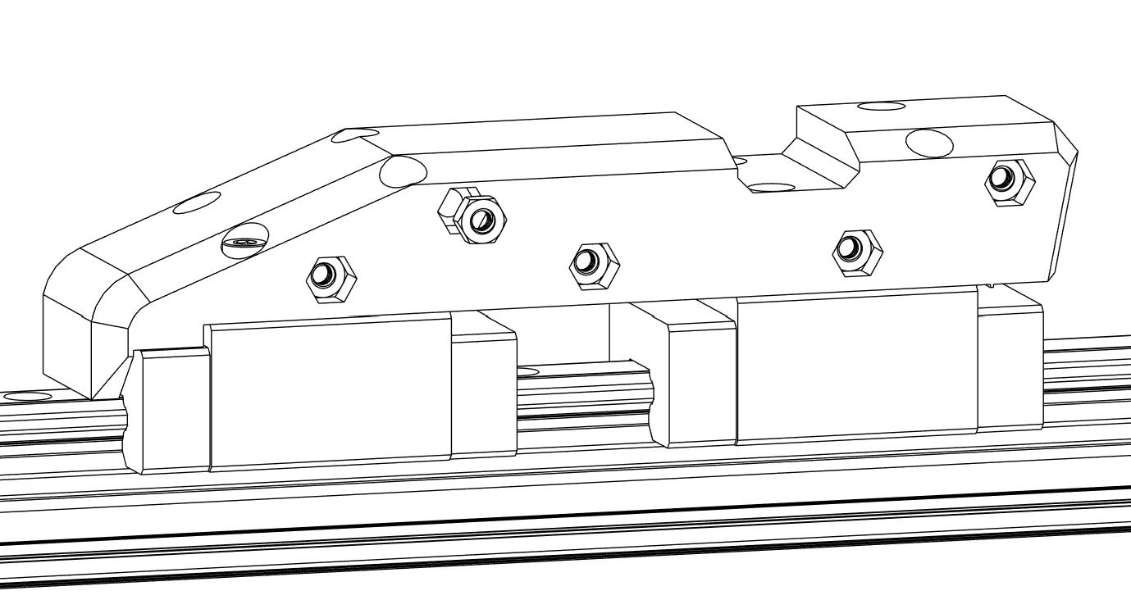

① Insert M4 nuts into both Y Axis linear rail mounts.

10 x M4 Nut

## Y Axis assembly

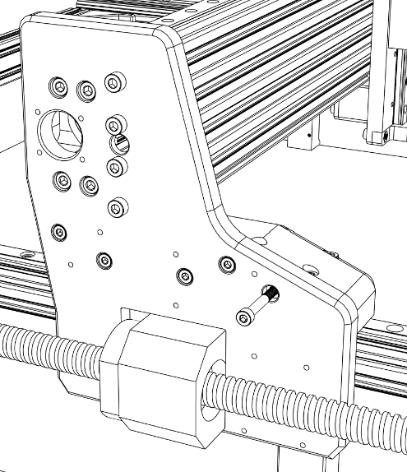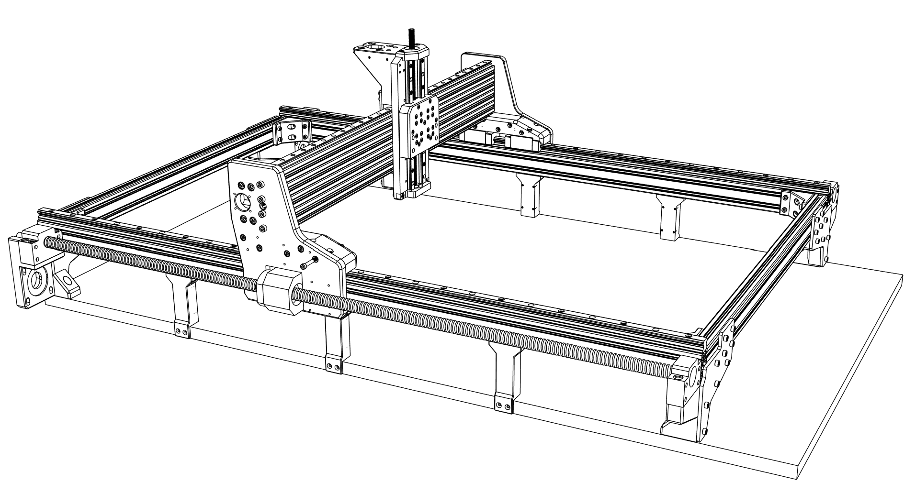

① Connect the X & Z assembly to the Y Axis linear rail mounts with M4x40 mm screws.

10 x M4x40 mm (Socket head)

## Y Axis assembly

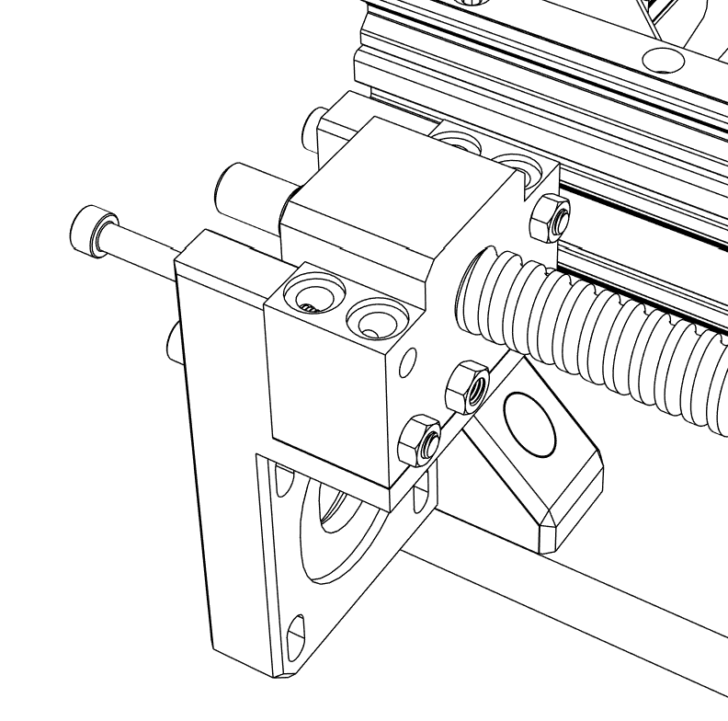

① Secure the ball screw housings to the Y axis motor mounts on each side with M5x50 mm screws and M5 nuts.

8 x M5x50 mm (Socket head)

8 x M5 Nut

## Y Axis assembly

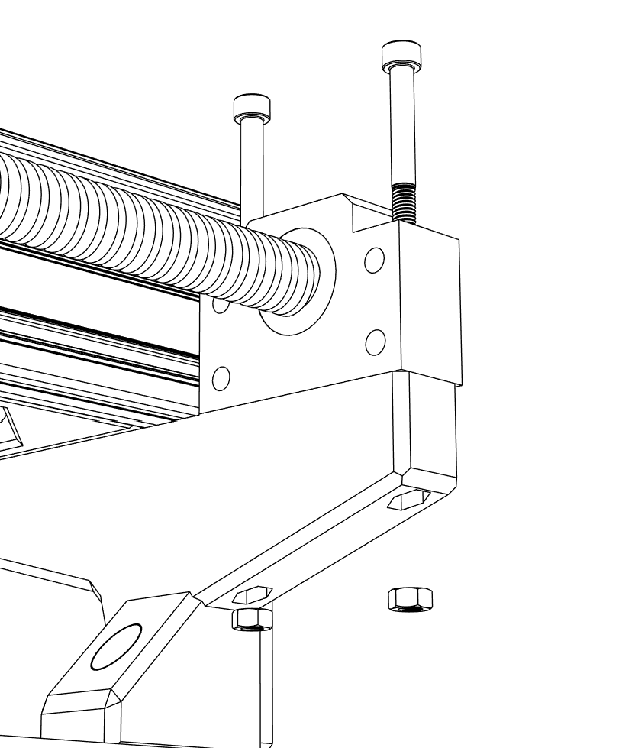

① Insert M5 nuts into the base mounts.

② Secure the ball screw housings to base mounts on each side with M5x50 mm screws.

4 x M5x50 mm (Socket head)

4 x M5 Nut

## Y Axis assembly

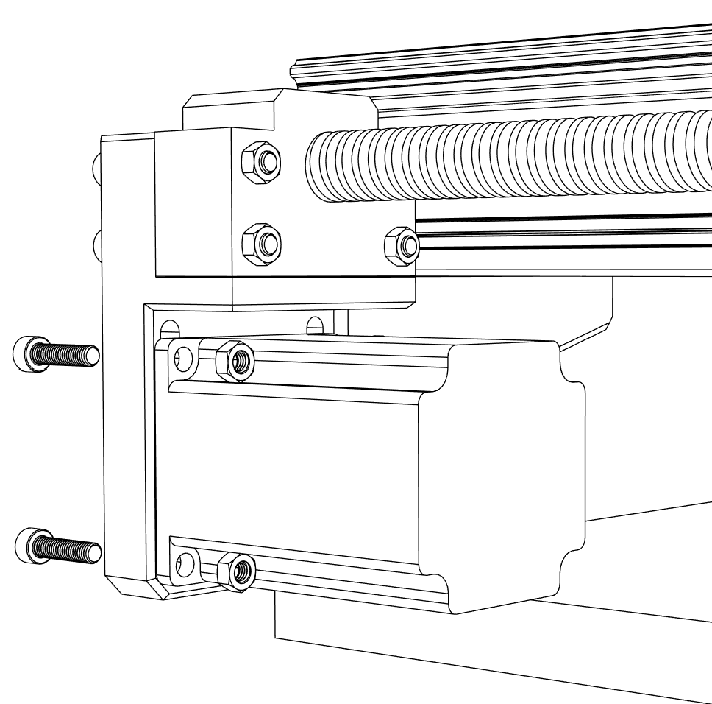

① Loosely install **Nema 23 stepper motor** on both sides to the Y axis motor mounts.

2 x Nema 23 76 mm (23HE30-2804S)

8 x M5x25 mm (Socket head)

8 x M5 Nut

## Stepper motors & belts installation

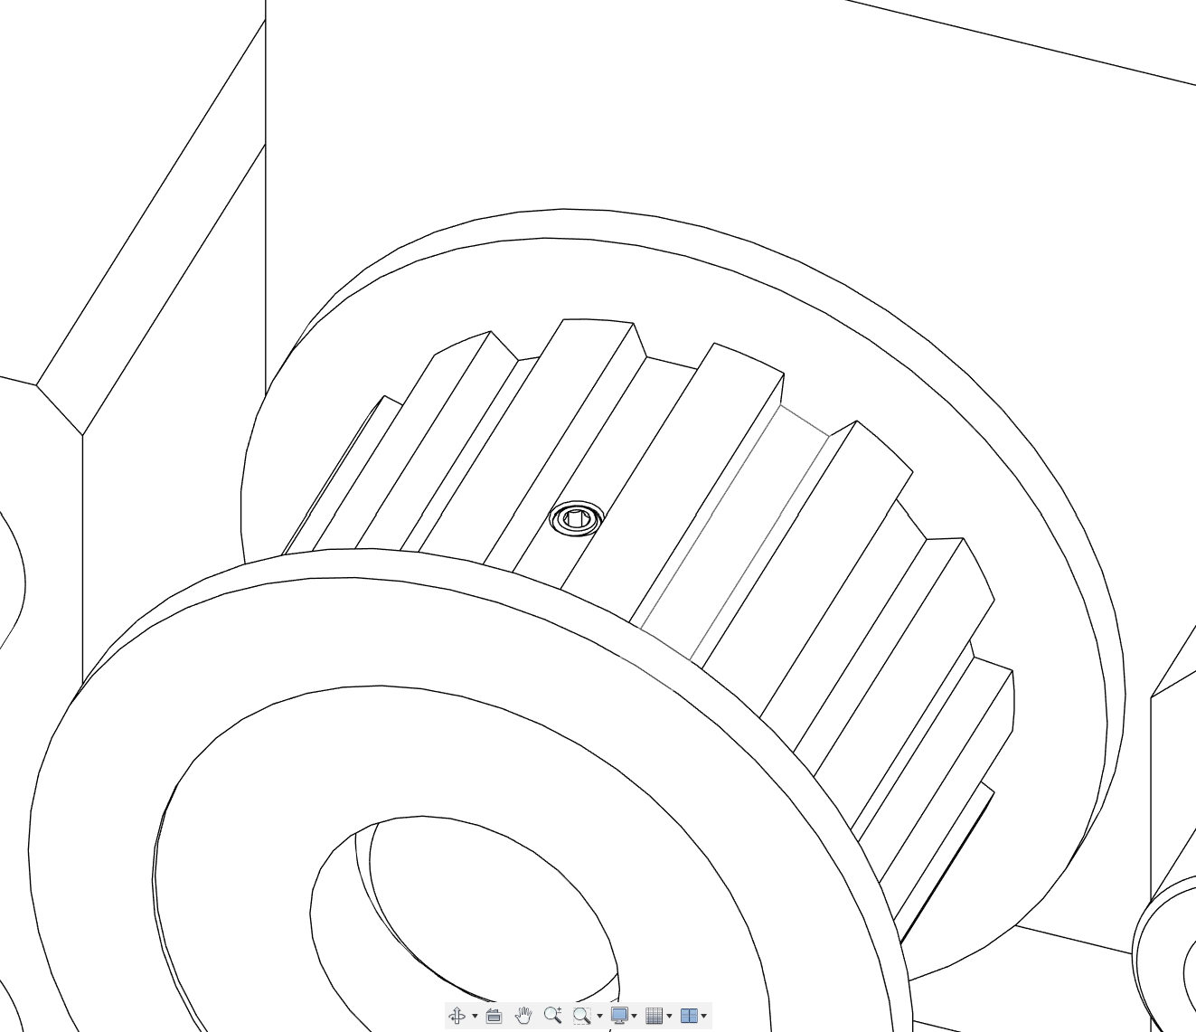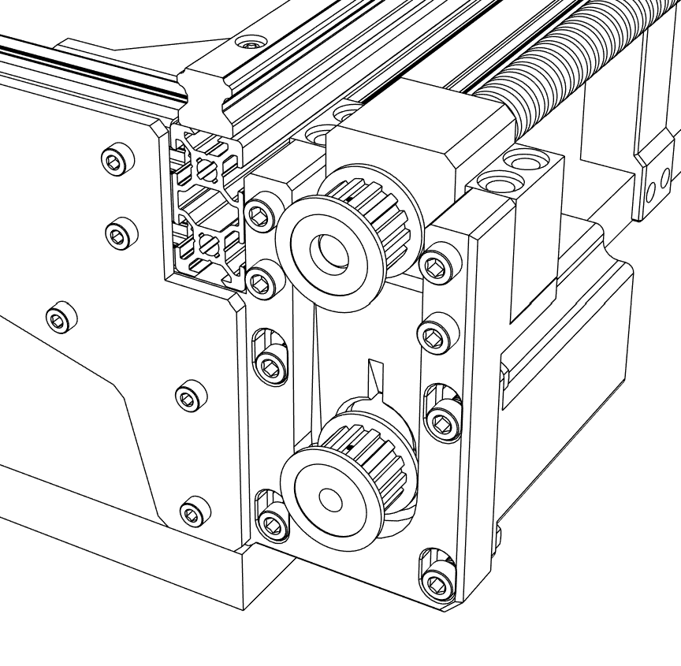

① Attach **T5 pulley (6.35 mm)** to the stepper motor shaft and **T5 pulley (10 mm)** to the ball screw on both sides.

② Secure all pulleys with setscrews.

2 x T5 Pulley 14T (6.35 mm bore)

2 x T5 Pulley 14T (10 mm bore)

## Stepper motors & belts installation

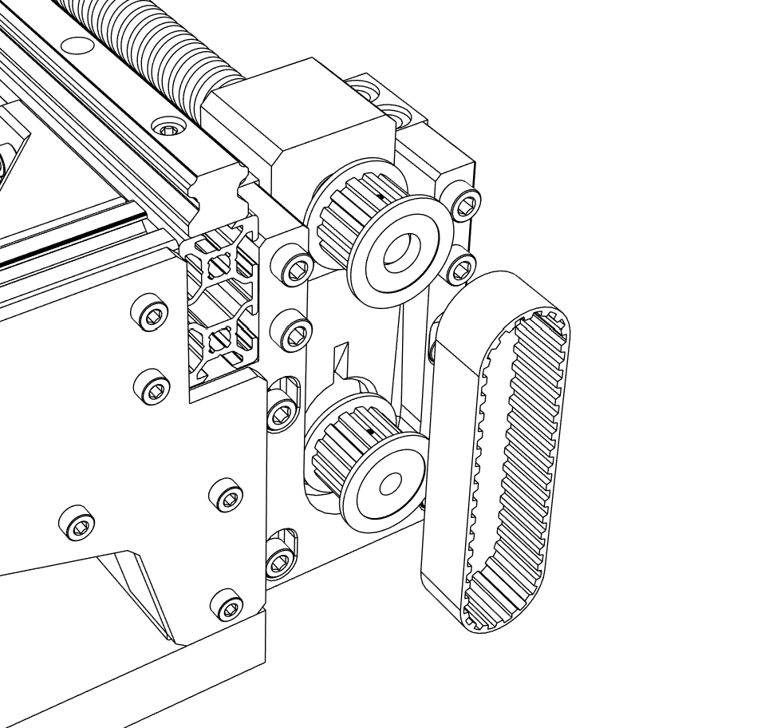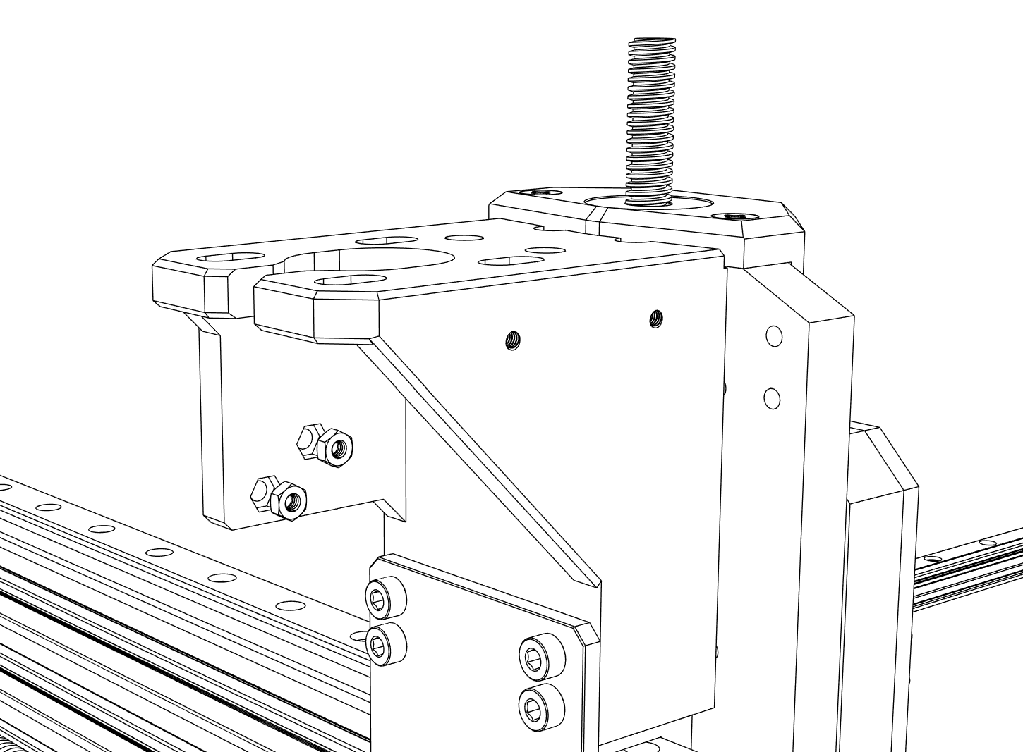

① Lift up the Y Axis motor and install the **synchronous T5 belt** on both sides of the CNC machine.

② Let the motor slide down and tighten it with screws.

2 x T5 synchronous belt – 200 mm

## Stepper motors & belts installation

① Press fit M3 nuts into the Z Axis motor mount.

2 x M3 Nut

## Stepper motors & belts installation

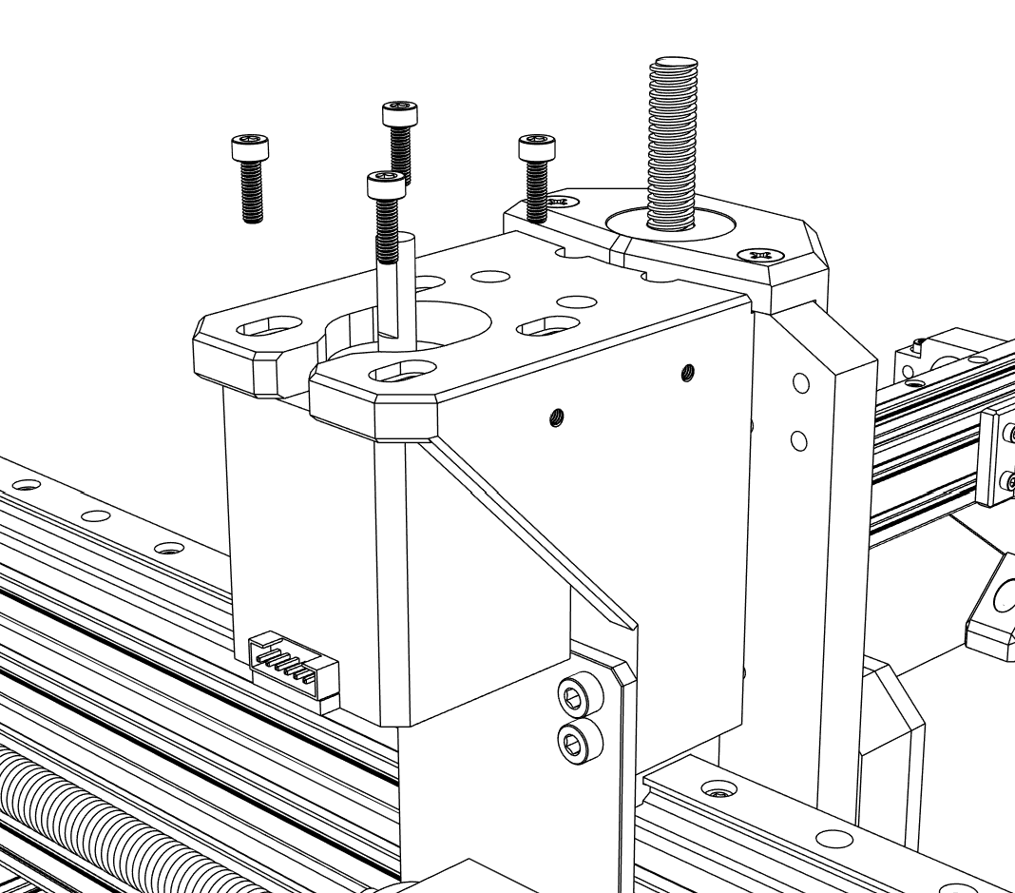

① Install the Z axis **Nema 17 stepper motor** with M3x10 mm screws.

1 x Nema 17 48 mm (17HE19-2004S)

4 x M3x10 mm (Socket head)

## Stepper motors & belts installation

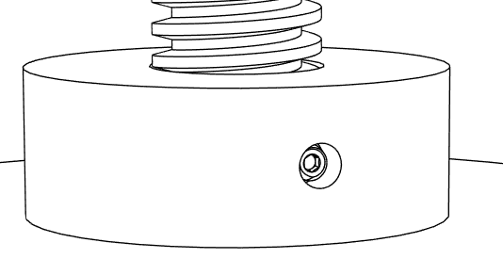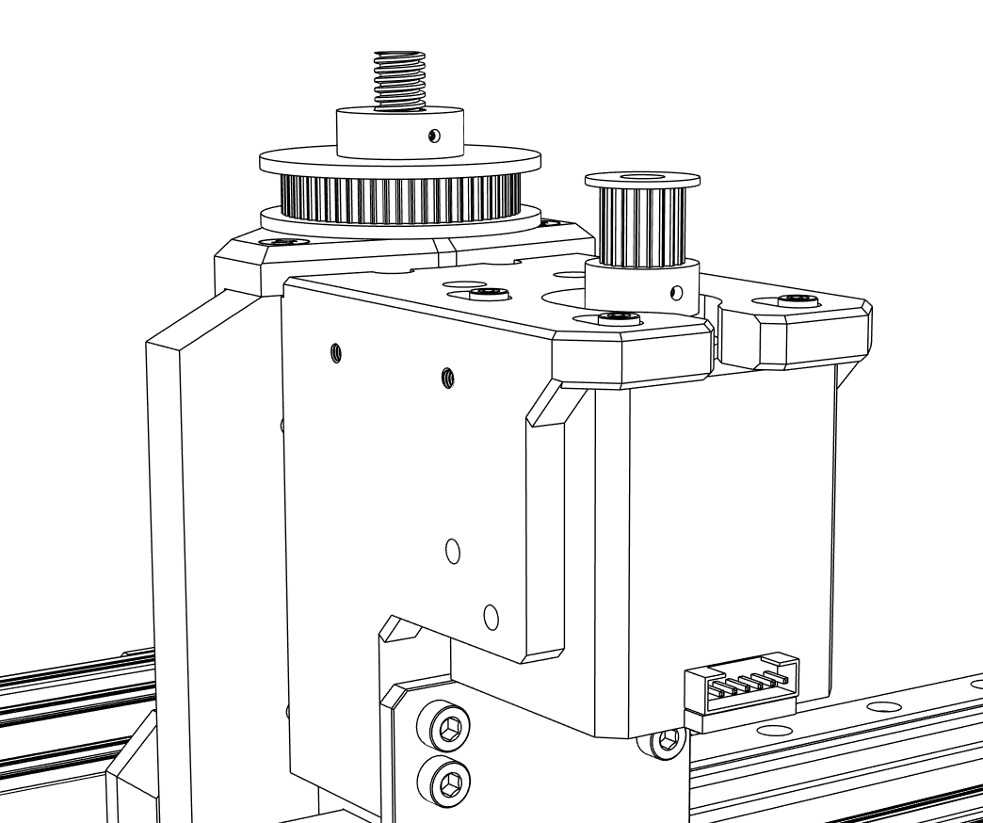

① Secure **GT2 Pulley 60T** and **20T** with setscrews.

1 x GT2 Pulley 60T

1 x GT2 Pulley 20T

## Stepper motors & belts installation

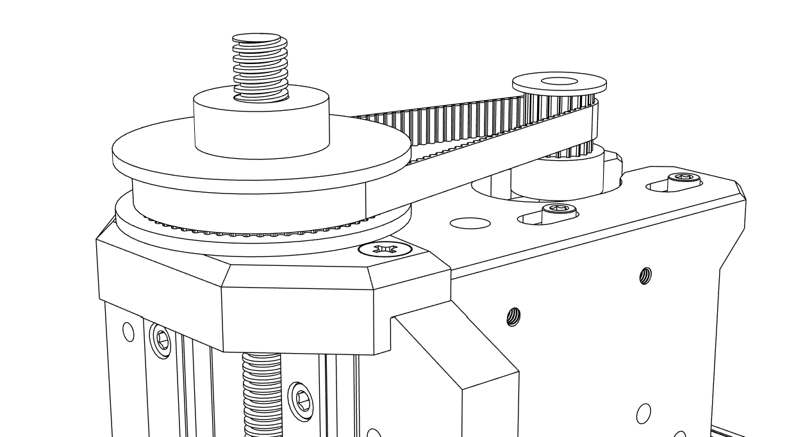

① Install the **Z axis GT2 synchronous belt**.

② Tighten the belt by sliding the Z axis motor and then secure it tightly with screws.

1 x GT2 synchronous belt – 200mm

## Stepper motors & belts installation

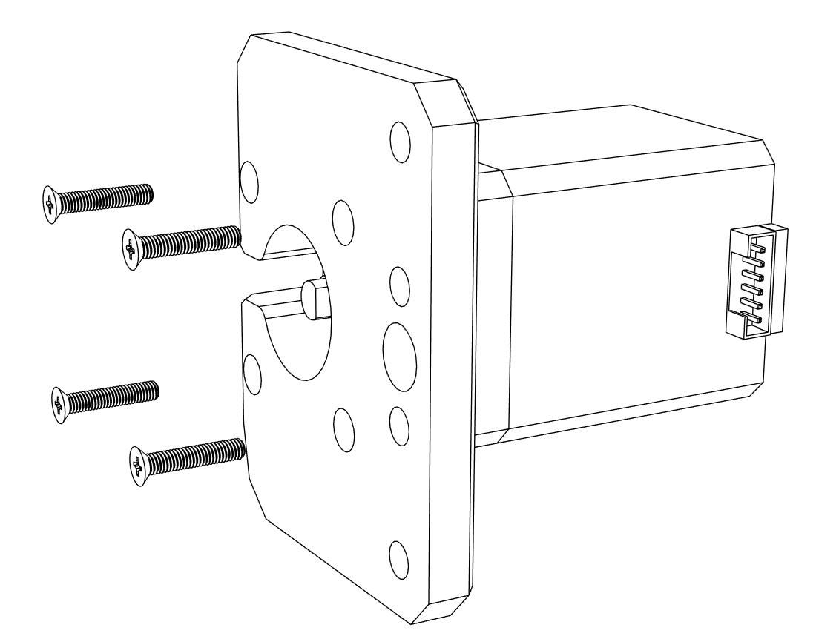

① Connect **Nema 17 stepper motor** to **X Axis motor mount** with M3x16 mm screws.

1 x Nema 17 48 mm (17HE19-2004S)

1 x X Axis motor mount

4 x M3x16 mm (Flat head)

## Stepper motors & belts installation

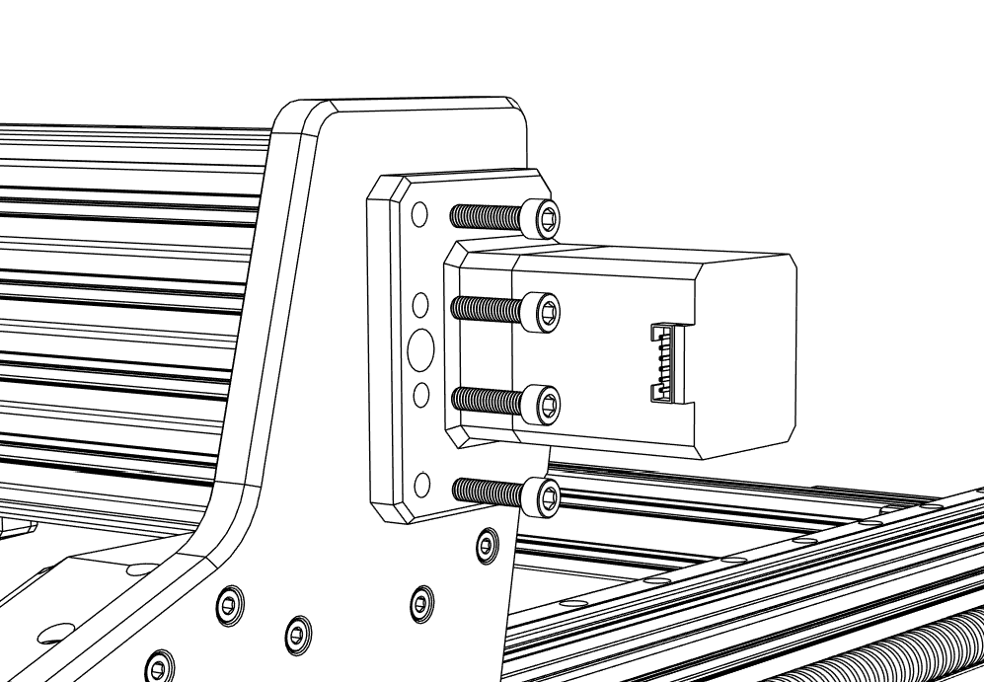

① Remove the temporary M5x20 mm screws connecting X Axis plate and 2080 aluminum profile.

② Attach the X axis motor and motor mount with M5x25 mm screws.

③ Secure the motor shaft in the coupler with setscrews.

4 x M5x25 mm

## Stepper motors & belts installation

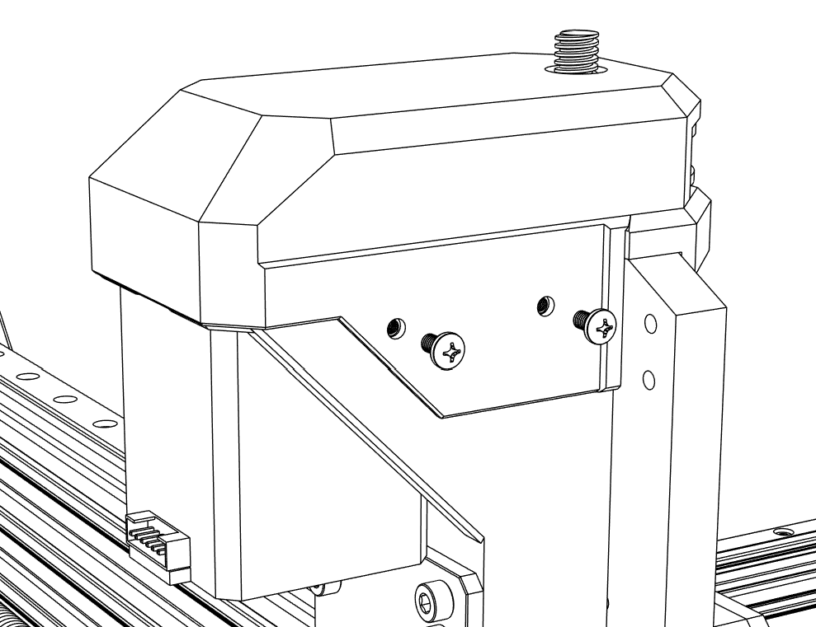

① Attach **Z Axis cover** with M3x5 mm screws.

1 x Z Axis cover

4 x M3x5 mm (Round head)

## Stepper motors & belts installation

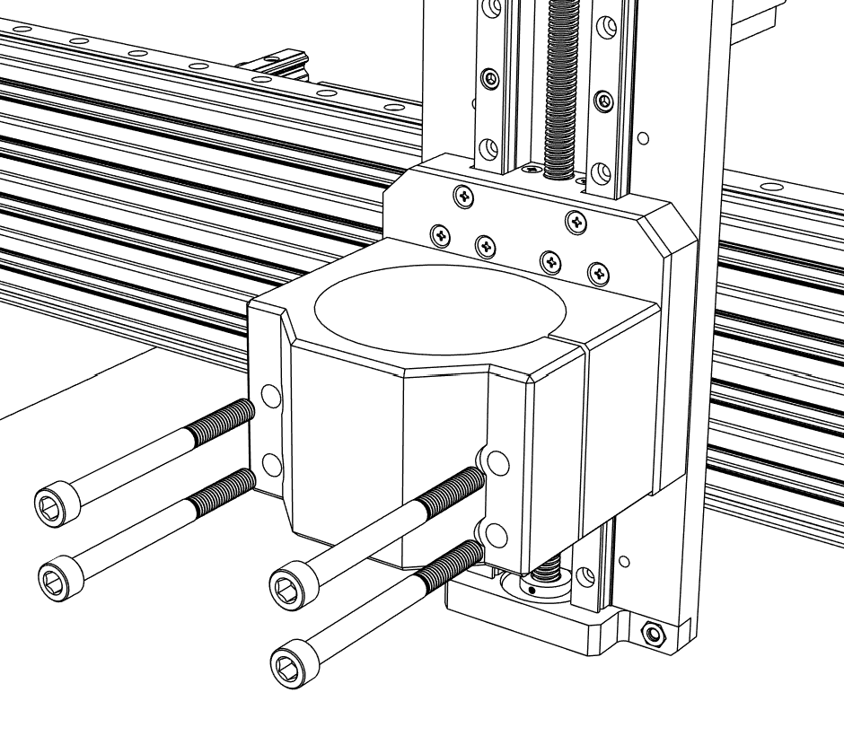

① Secure the **Spindle mount** with M6x70 mm screws.

② Keep the screws loose before installing Spindle motor.

1 x Spindle mount

4 x M6x70 mm (Socket head)

## Spindle installation

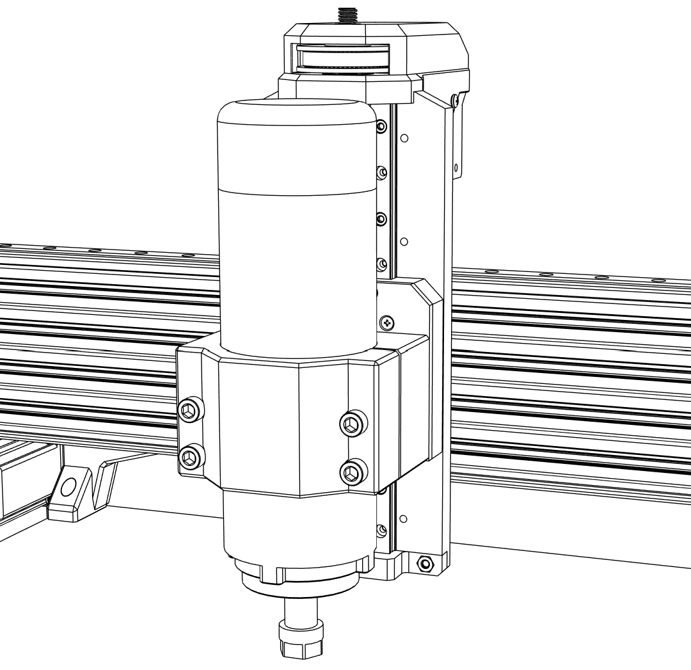

① Insert **Spindle motor** into the mount and tighten the screws.

1 x Spindle motor

## Spindle installation

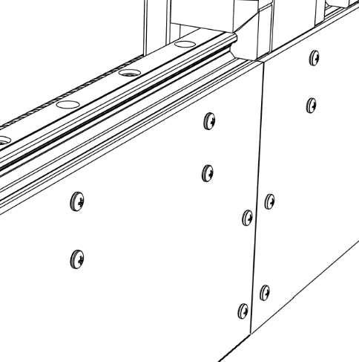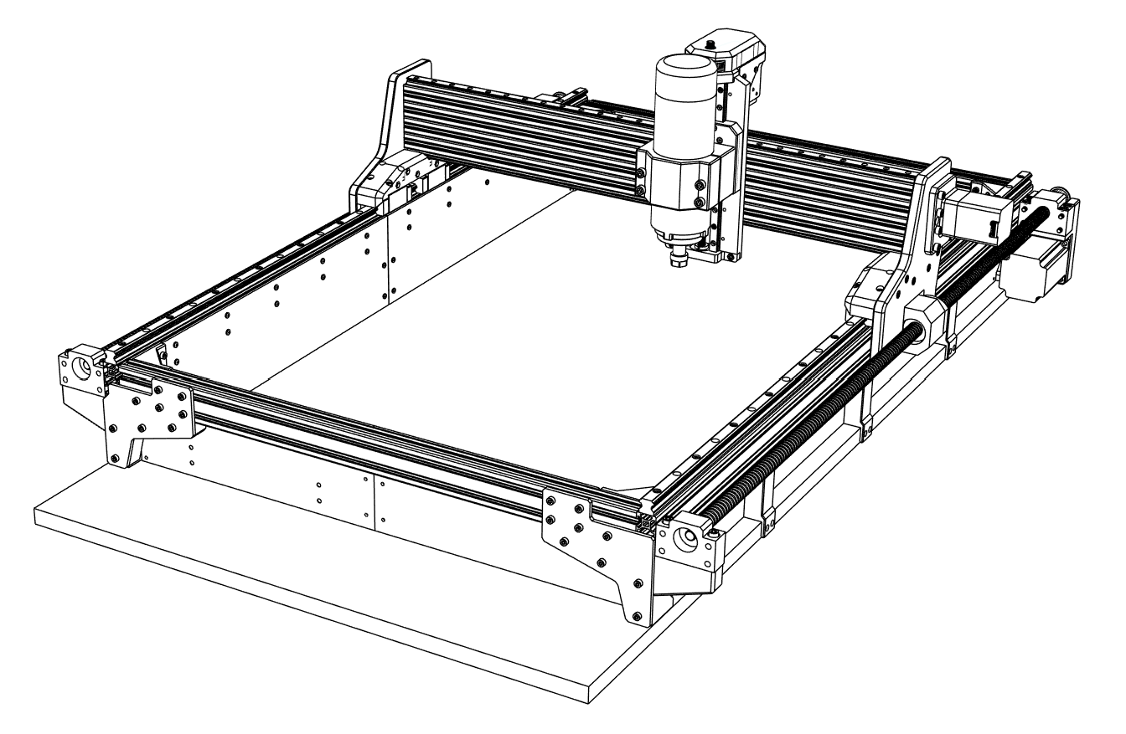

① Install all **acrylic sheets** with M3x5 mm screws and T-slot nuts.

② Install **Electronics panels REAR** with M3x5 mm screws and T-slot nuts.

4 x Acrylic sheet SIDE

2 x Acrylic sheet REAR

1 x Electronics panel REAR R

1 x Electronics panel REAR L

72 x M3x5 mm (Round head)

64 x M3 T-slot nut

## Side panels

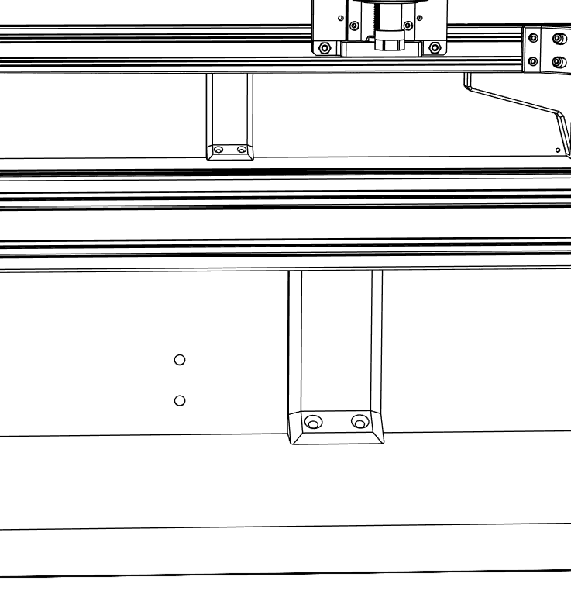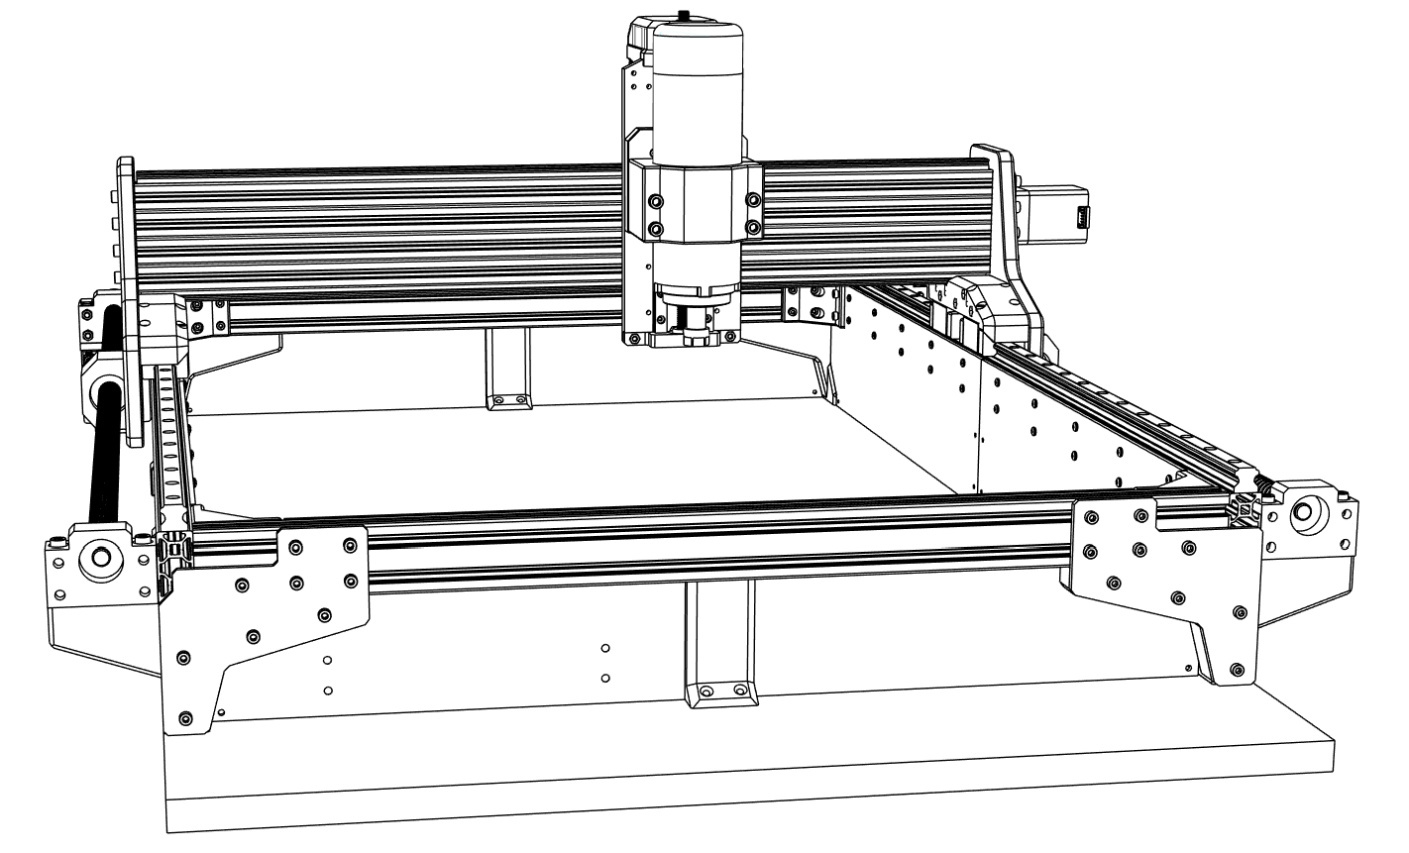

① Connect rear acrylic sheets and electronics panels with **Base support REAR** parts and M3x5 mm screws.

2 x Base support REAR

8 x M3x5 mm (Round head)

4 x 3x20mm wood screw (Flat head)

## Side panels

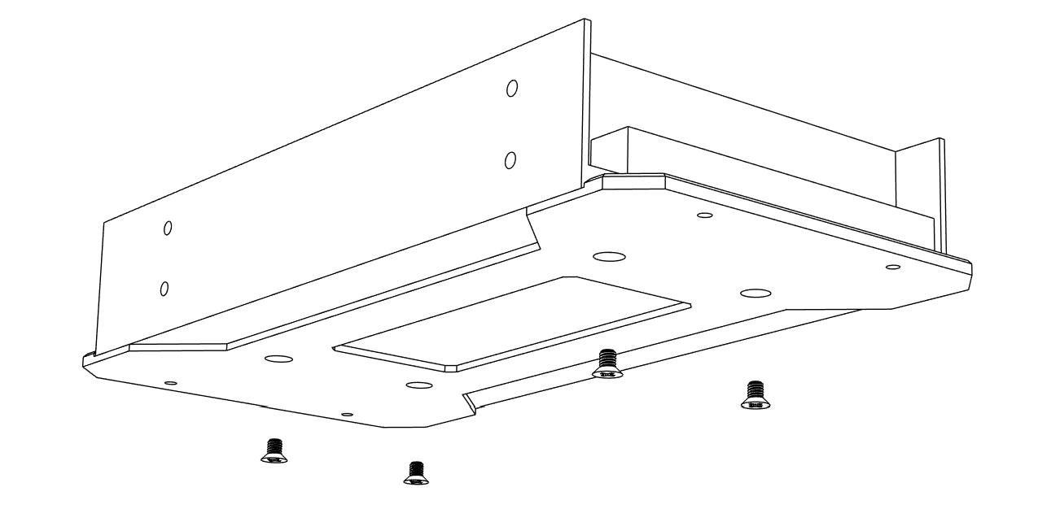

① Attach **PSU Mount BOT** to the **Meanwell power supply** with M4x6 mm screws.

1 x Meanwell LRS-600-48 PSU

1 x PSU Mount BOT

4 x M4x6 mm (Flat head)

## Electronics

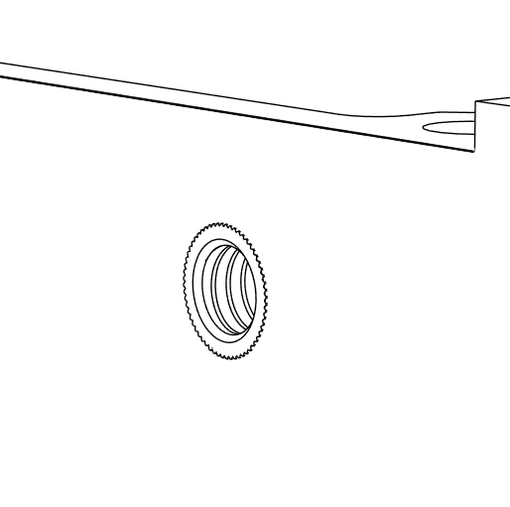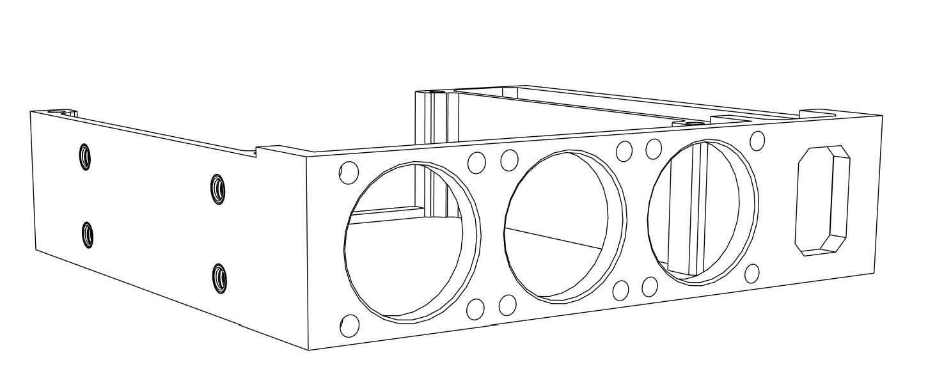

① Insert M4 threaded inserts into **PCK Controller mount** using soldering iron.

1 x PCK Controller mount

8 x M4 Threaded inserts

## Electronics

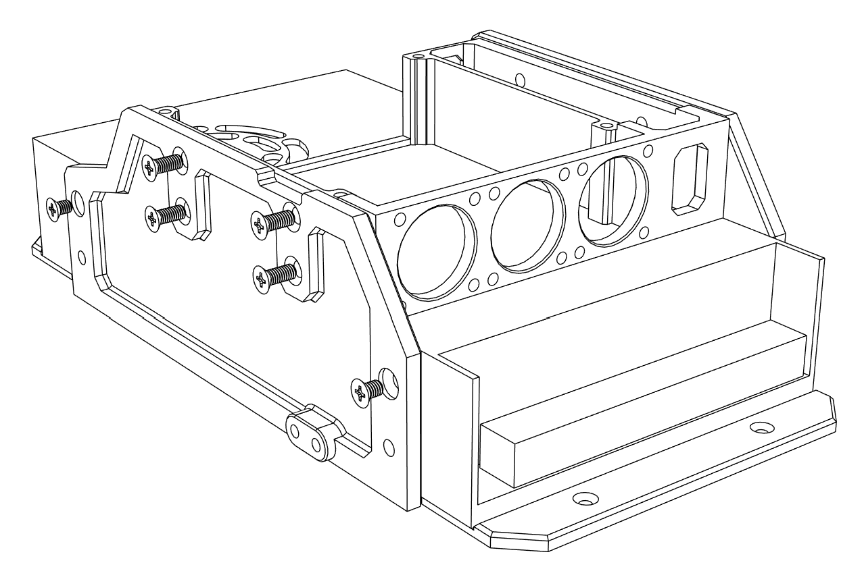

① Connect **PSU mounting plates** with PCK Controller mount using M4x10 mm screws.

② Attach the previous assembled parts to PSU with M4x6 mm screws.

1 x PSU Mounting plate A

1 x PSU Mounting plate B

2 x M4x6 mm (Flat head)

8 x M4x10 mm (Flat head)

## Electronics

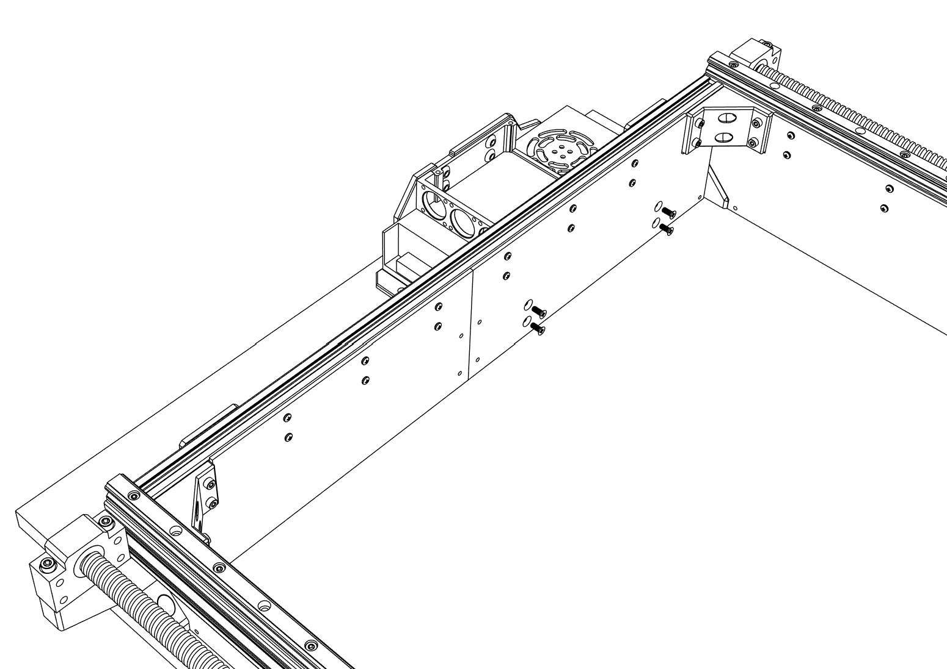

① Secure the PSU to the electronics rear covers with M4x10 mm screws according to the picture above.

4 x M4x10 mm (Flat head)

## Electronics

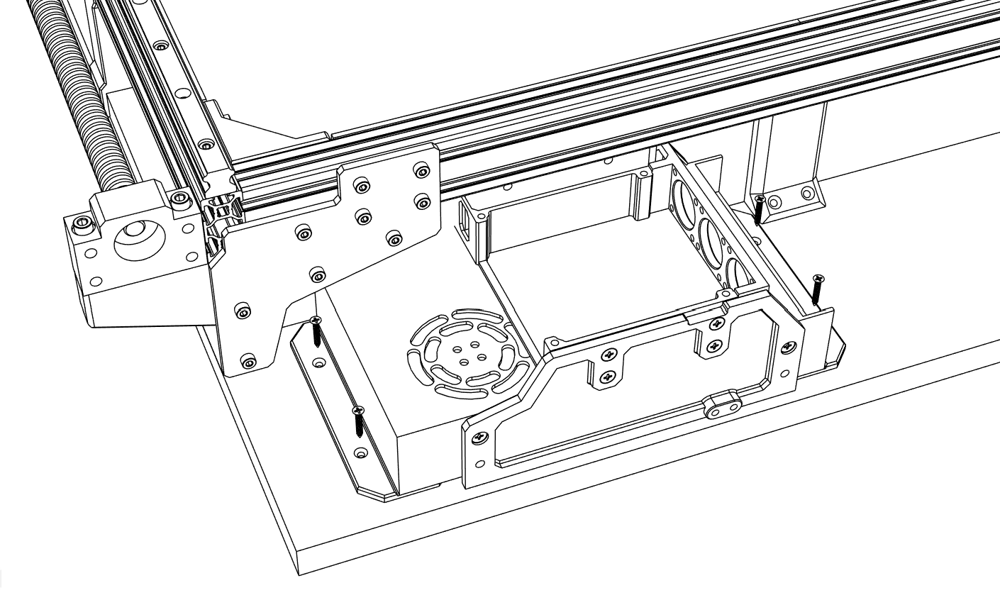

① Further secure the PSU with 3x20 mm wood screws to the MDF board.

4 x 3x20mm wood screw (Flat head)

## Electronics

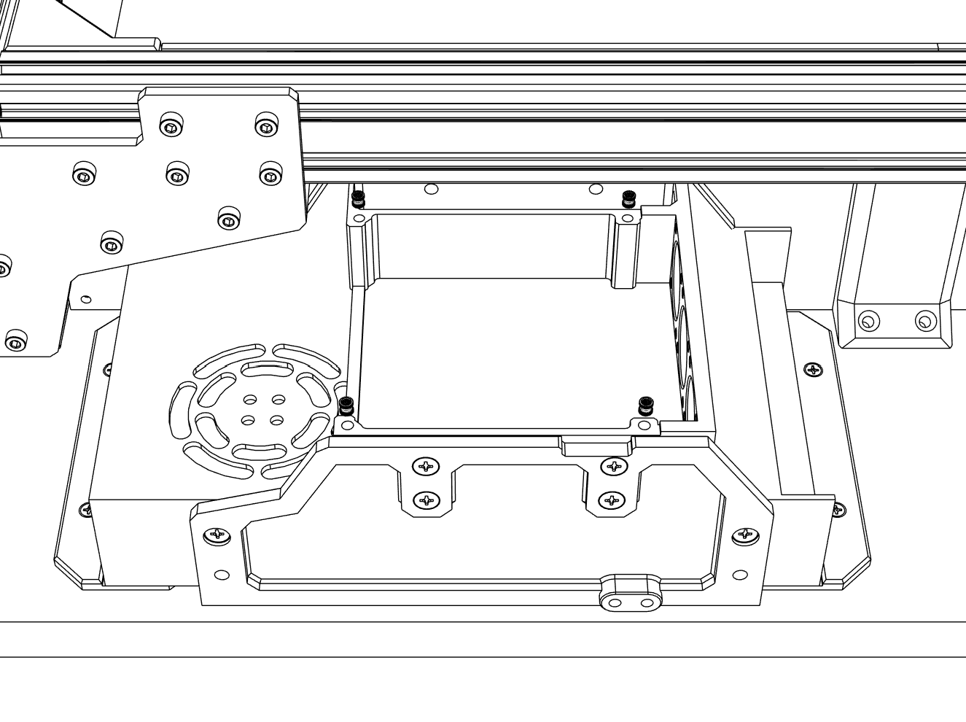

① Install M3 threaded inserts to the PCK Controller mount using a soldering iron.

4 x M3 Threaded insert

## Electronics

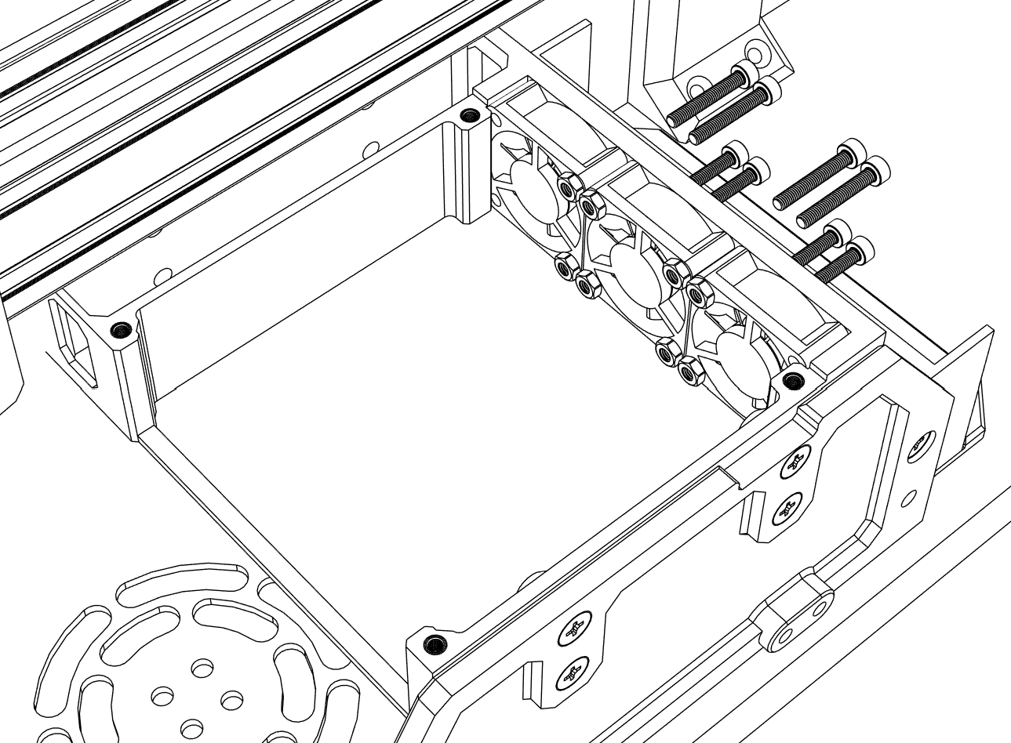

① Install three **3010 fans** with M3x20mm screws and M3 nuts.

② Fan cable should come out at the top side of the fan for easier connection to the board.

3 x Fan 3010 12V

6 x M3x20 mm (Socket head)

6 x M3 Nut

## Electronics

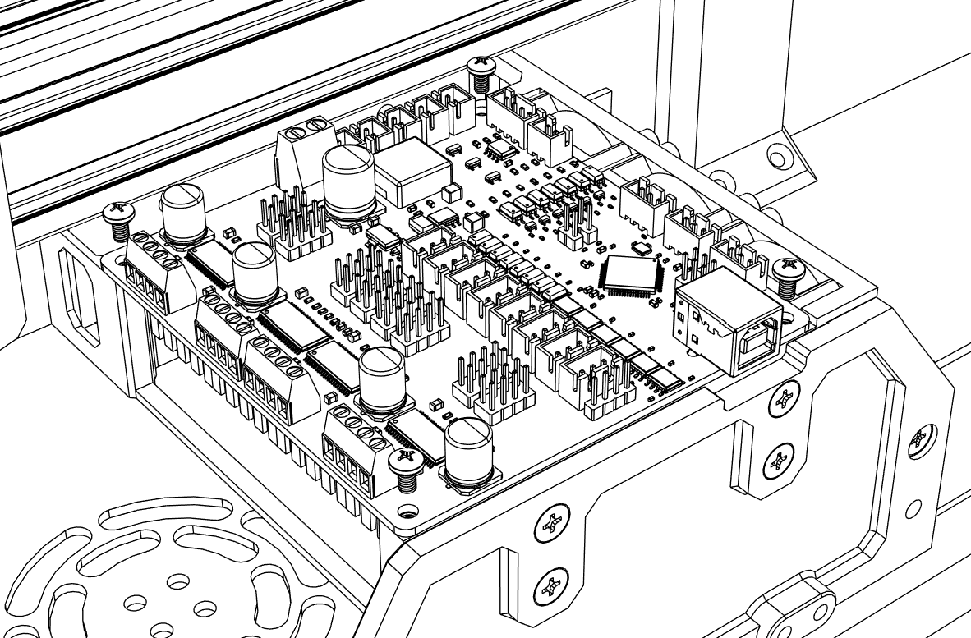

① Install the **PCK Controller** as shown above with M3x5 mm screws.

1 x PCK Controller

4 x M3x5 mm (Round head)

## Electronics

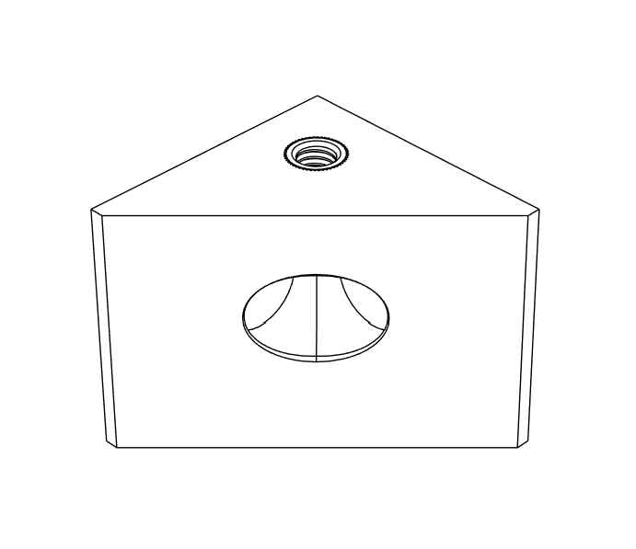

① Insert M3 threaded inserts to all 14 **Electronics panel corner connectors.**

14 x Electronics panel corner connector

14 x M3 Threaded insert

## Electronics

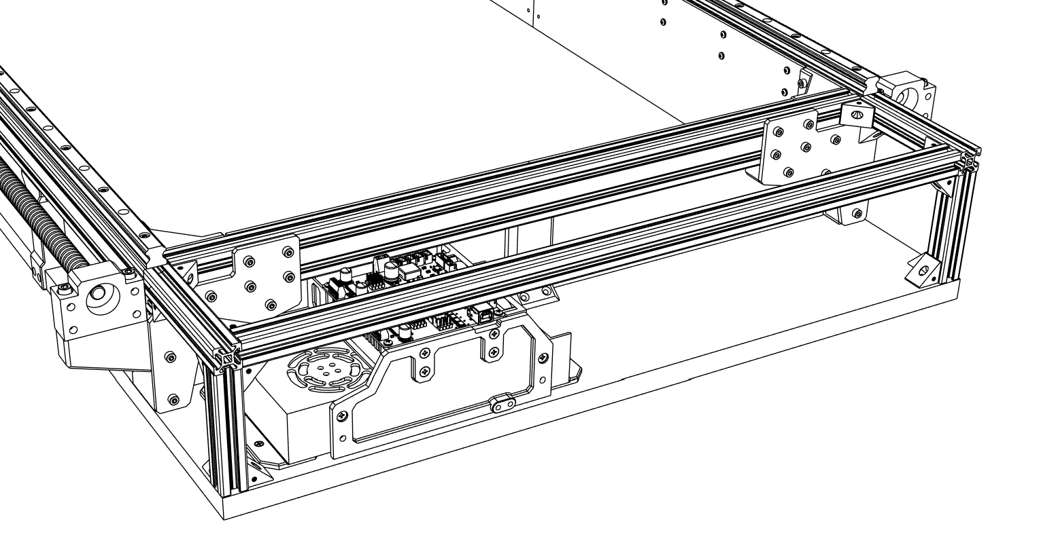

① Connect the rest of the **aluminum profiles** with the corner connectors and M3x10 mm screws to form electronics enclosure frame.

② Secure the frame via the corner connectors to the MDF board with 3x20 mm wood screws.

1 x Aluminum profile 2020 – 600 mm

2 x Aluminum profile 2020 – 120 mm

2 x Aluminum profile 2020 – 95 mm

22 x M3x10 mm (Flat head)

22 x M3 T-slot nut

4 x 3x20 mm wood screw (Flat head)

## Electronics

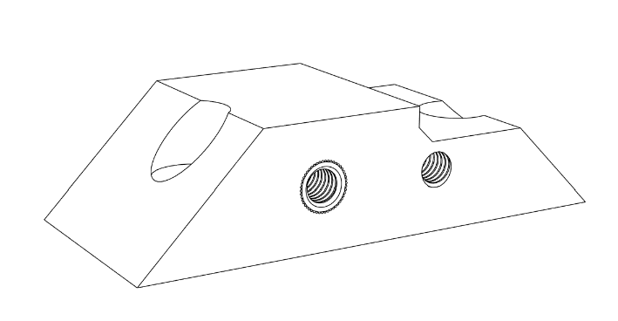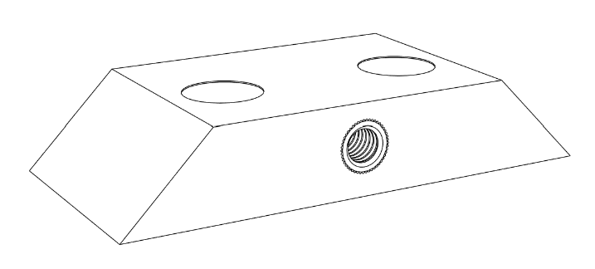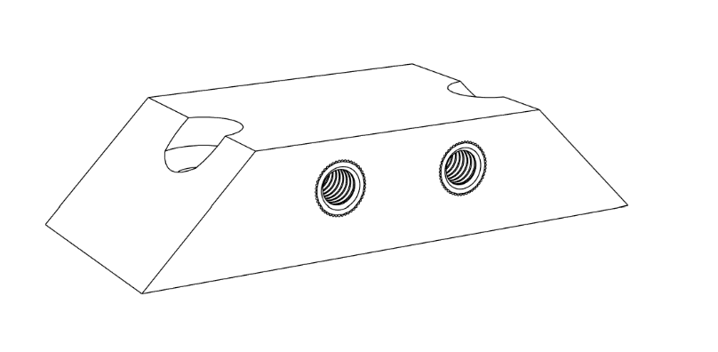

① Insert M3 threaded inserts to all **Panel connectors** as shown in the picture.

9 x Panel connector A

6 x Panel connector B

1 x Panel connector C

23 x M3 Threaded screws

## Electronics

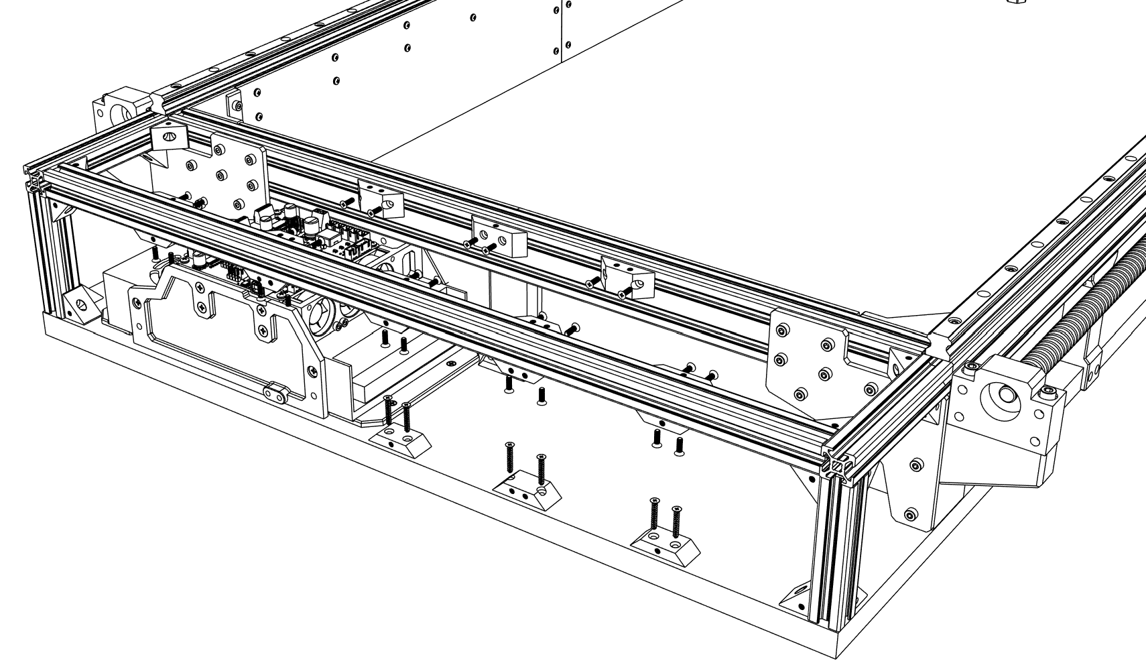

① Connect Panel connectors to aluminum profiles with M3x10 mm screws according to the picture.

② Distance between the closest holes of neighboring connectors should be 95 mm.

26 x M3x10mm (Flat head)

26 x M3 T-slot nut

6 x 3x20 mm wood screw (Flat head)

## Electronics

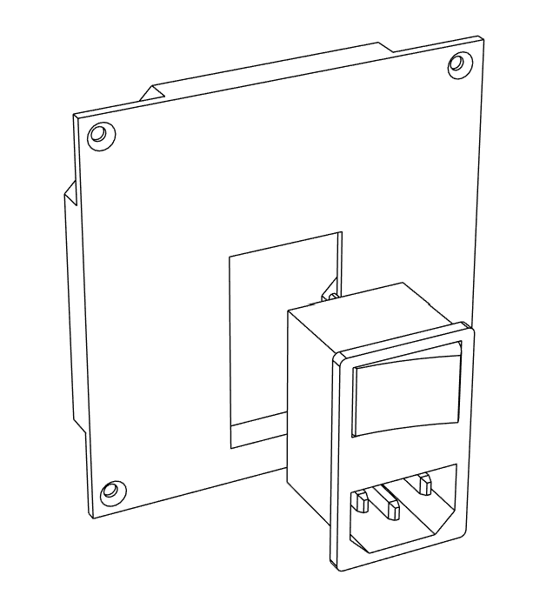

① Click the power socket into the **Electronics panel RIGHT.**

1 x Electronics panel RIGHT

1 x Power socket AC-04B

## Electronics

① Install **GX12-4 connectors** in the first row (for stepper motors) and **GX12-2 connectors** in the remaining slots.

② Install **GX20-4 connector** for the spindle to the largest slot.

③ It is recommended to start wiring at this point (can be done later but requires removing some covers).

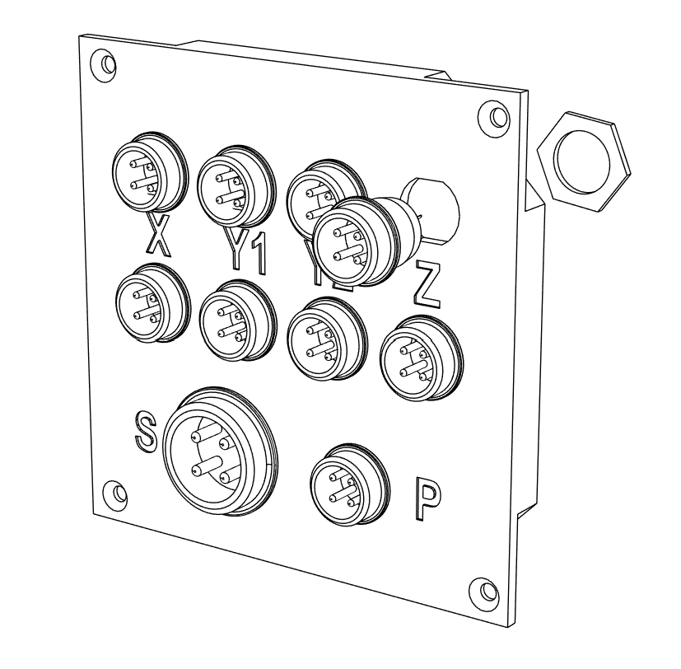

4 x GX12-4 connector

5 x GX12-2 connector

1 x GX20-4 connector

## Electronics

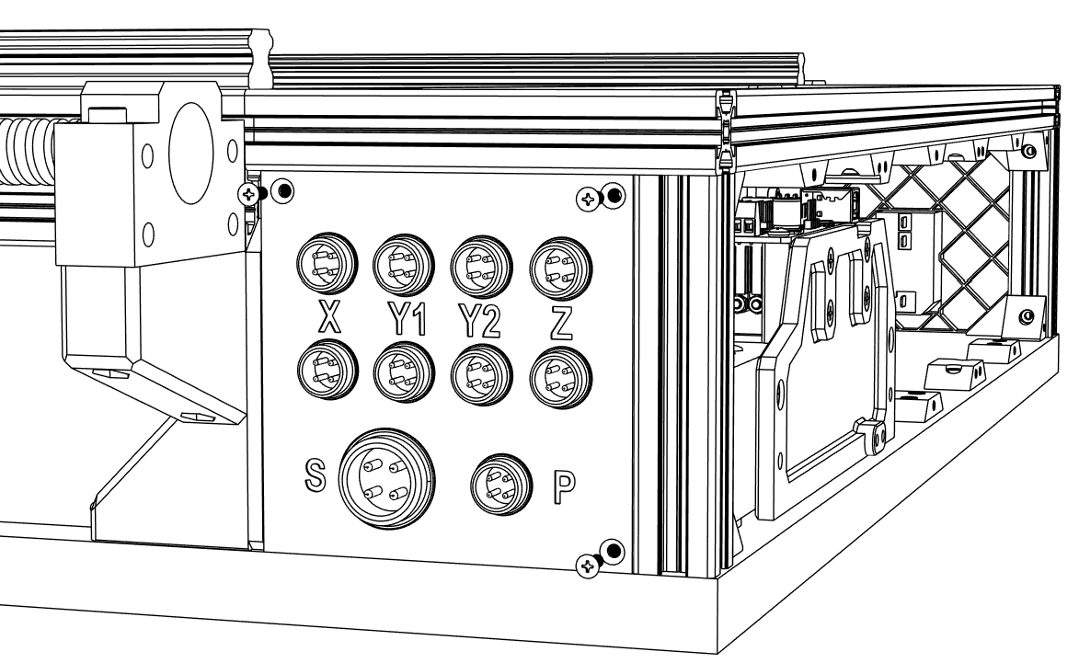

① Install the electronics side panels on both sides with M3x8 mm screws.

6 x M3x8 mm (Flat head)

## Electronics

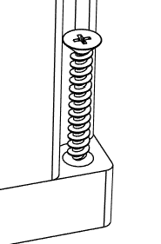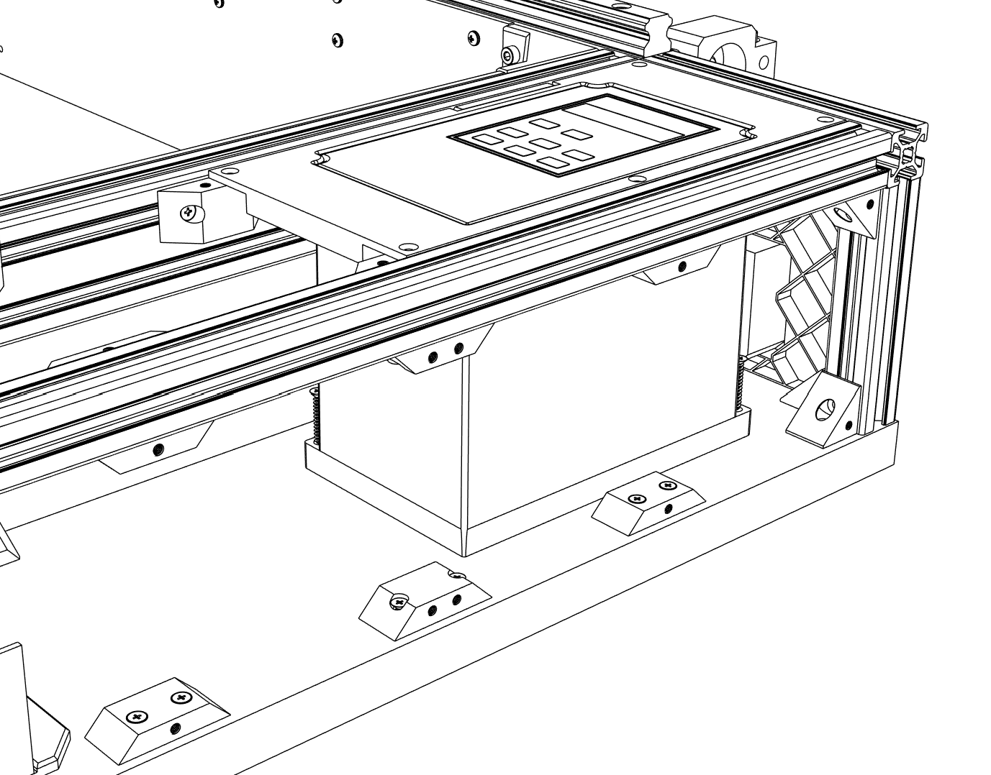

① Install the **1.5kW VFD** and secure it with two 3x20 mm wooden screws to the MDF board.

② Make sure to position the VDF such that the **Electronics panel TOP R** can fit perfectly.

1 x Vevor A2-8015 (1.5 kW VFD)

1 x Electronics panel TOP R

2 x 3x20 mm wood screw (Flat head)

## Electronics

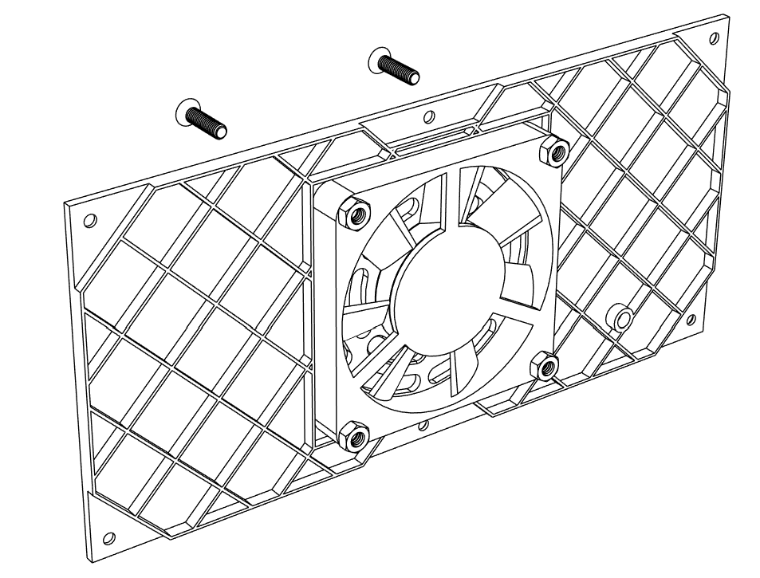

① Attach **7015 fan** to the **Electronics panel FRONT M** with M4x20 mm screws and M4 nuts.

② It is recommended that the cable comes from the fan at the bottom side.

1 x Electronics panel FRONT M

1 x Fan 7015 12V

4 x M4x20 mm (Flat head)

4 x M4 Nut

## Electronics

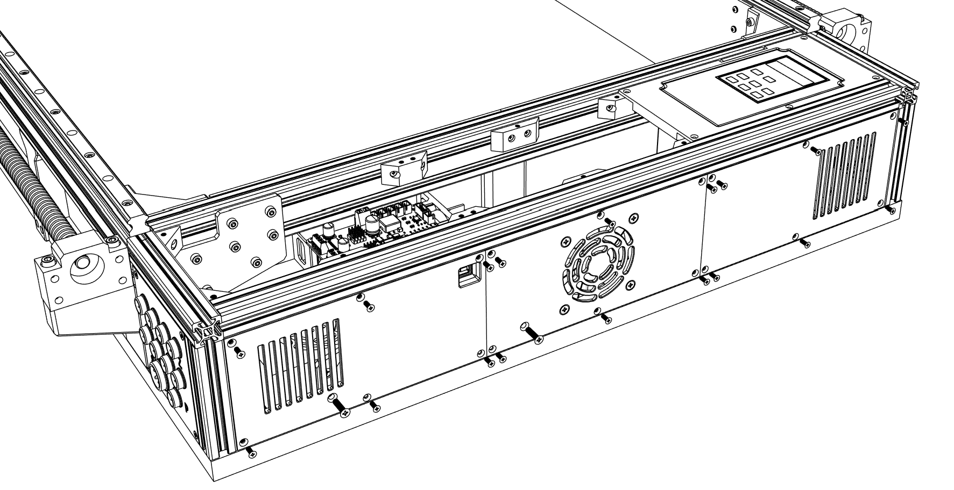

① Install all the **Electronics panels FRONT (L, M, R)** with M3x8 mm screws.

② Secure the panels to the PSU with M4x16 mm screws.

1 x Electronics panel FRONT R

1 x Electronics panel FRONT L

18 x M3x8 mm (Flat head)

2 x M4x16 mm (Flat head)

## Electronics

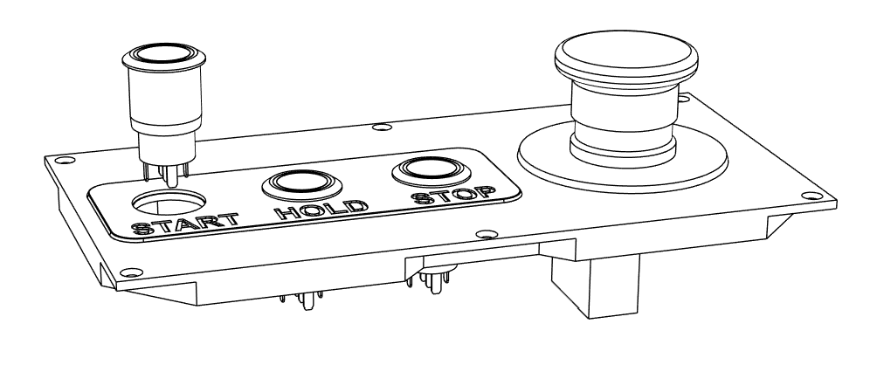

① Install **19mm buttons** by sliding them through the **Control panel label** and **Electronics panel TOP M**.

② It is recommended to use green button for START, blue for HOLD and red for STOP but it can be customized to users liking.

③ Install **XB2-542 emergency button** into the largest hole.

1 x Electronics panel TOP M

1 x Control panel label

3 x Button (Red,Green,Blue) – 19 mm

1 x Emergency button XB2-542

## Electronics

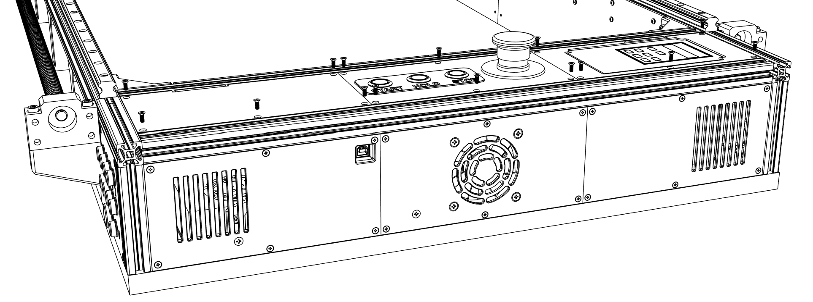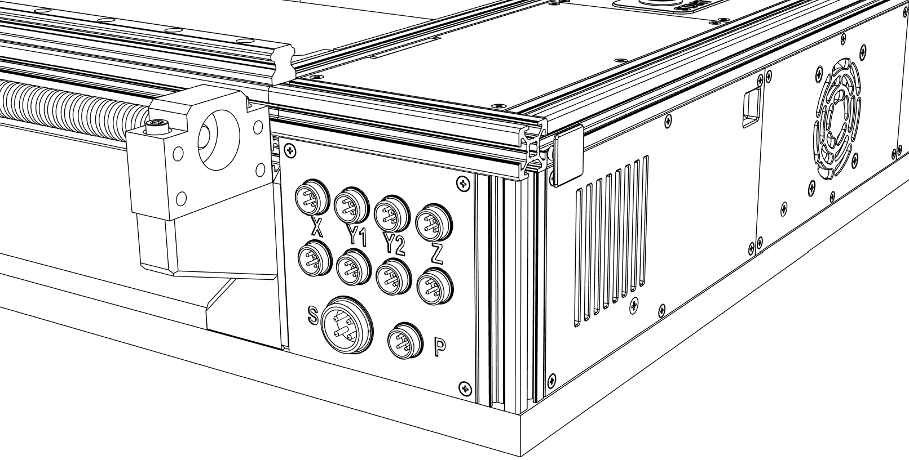

① Secure all **Electronics panels TOP (L, M, R)** with M3x8 mm screws.

1 x Electronics panel TOP L

16x M3x8 mm (Flat head)

## Electronics

① Cover the open aluminum profiles with **2020 end plugs**.

2 x 2020 end plug

## Electronics

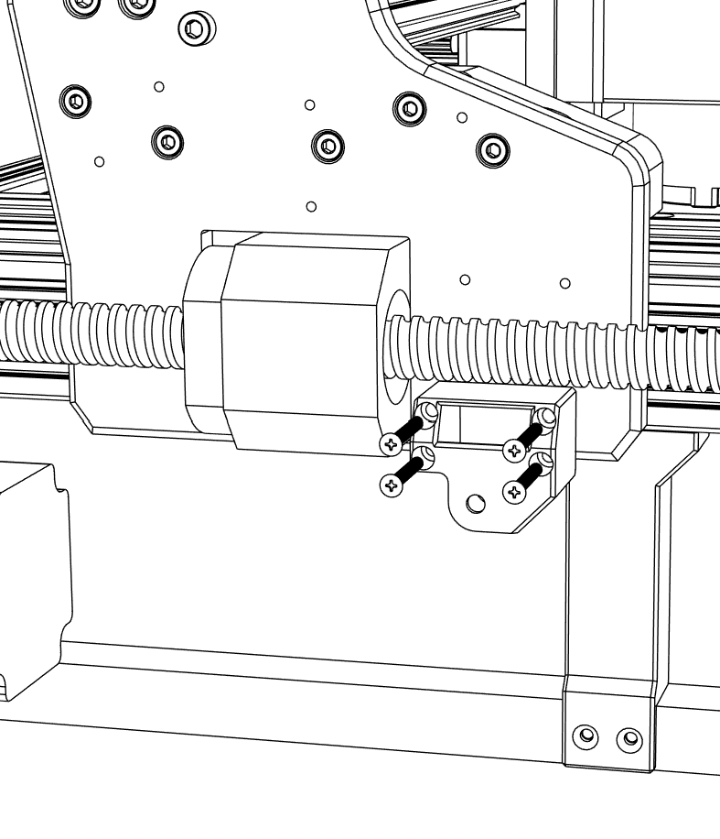

① Attach **Y Axis cable chain mount REAR** to the right X axis plate with M3x25 mm screws.

1 x Y Axis cable chain mount REAR

4 x M3x25 mm (Flat head)

## Cable chains

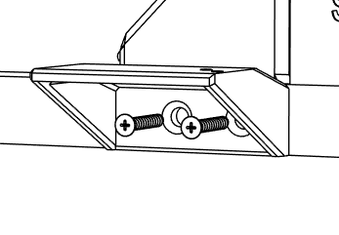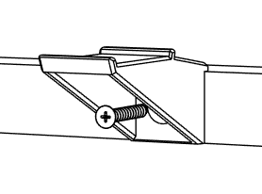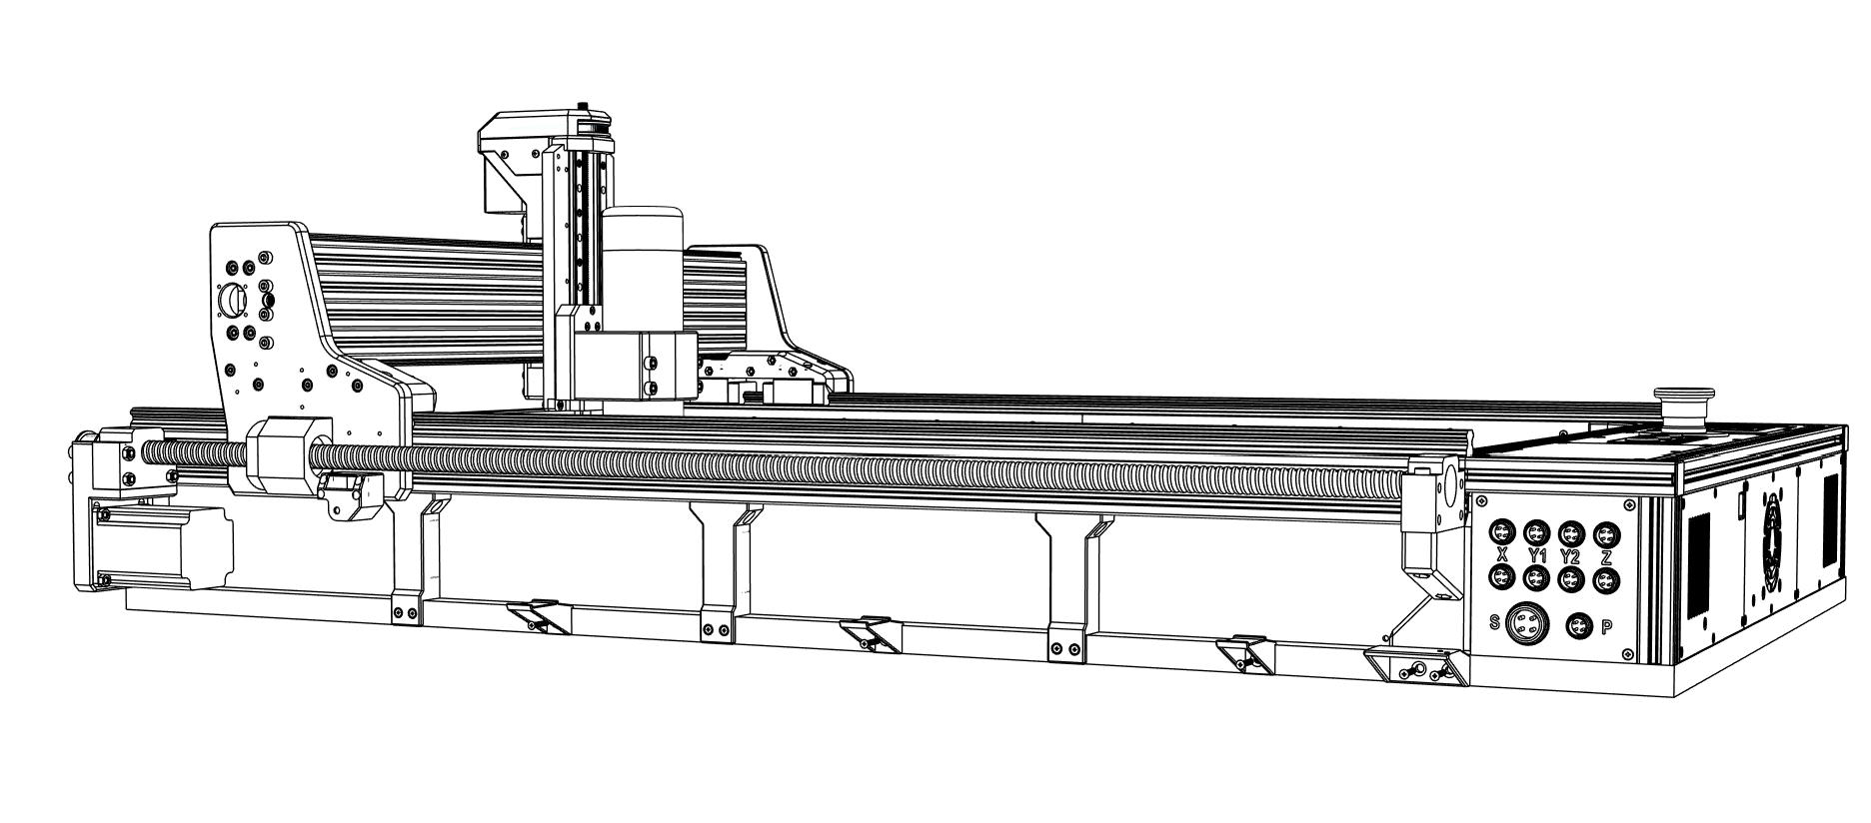

① Secure **Y Axis cable chain supports** and **Y Axis cable chain mount FRONT** with 4x20 mm wood screws.

3 x Y Axis cable chain support

1 x Y Axis cable chain mount FRONT

5 x 4x20 mm wood screw (Flat head)

## Cable chains

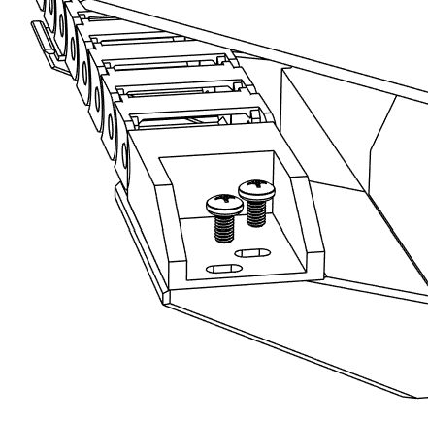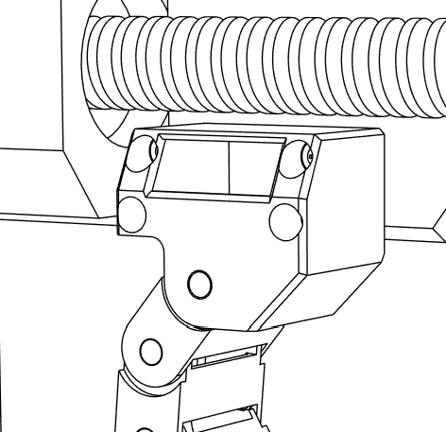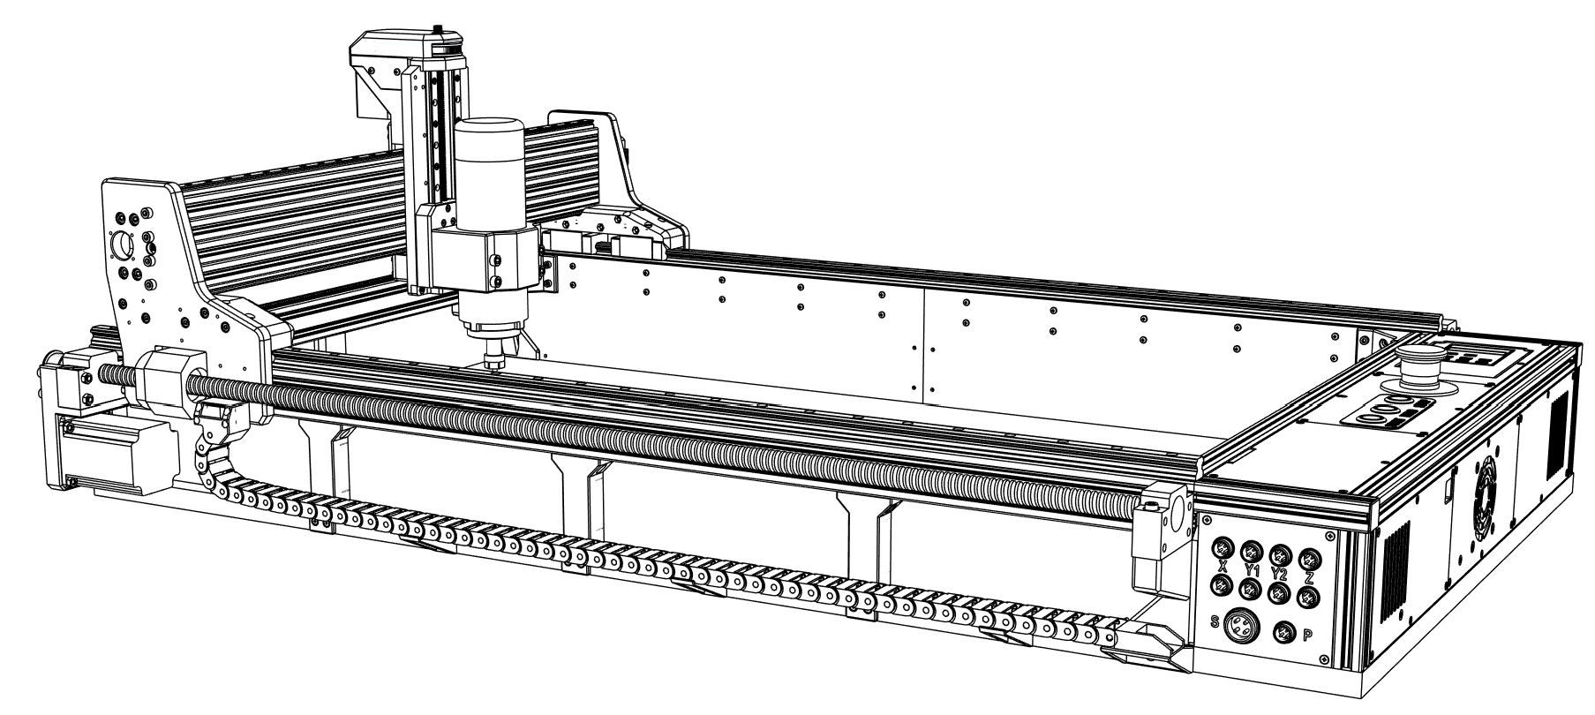

① Install around **90 cm of cable chain** (±1 chain link) and secure it in the front with M3x5 mm screws.

1 x Cable chain (90 cm)

2 x M3x5 mm (Round head)

## Cable chains

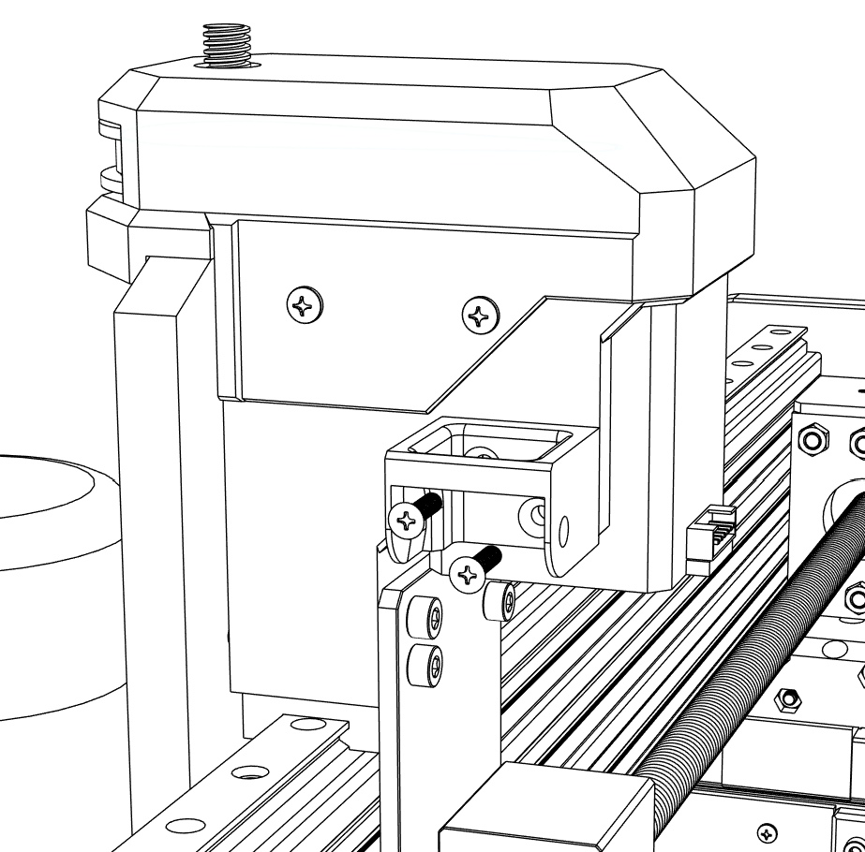

① Attach **X Axis cable chain mount** to the Z Axis motor mount with M3x12 mm screws.

1 x X Axis cable chain mount

2 x M3x12 mm (Flat head)

## Cable chains

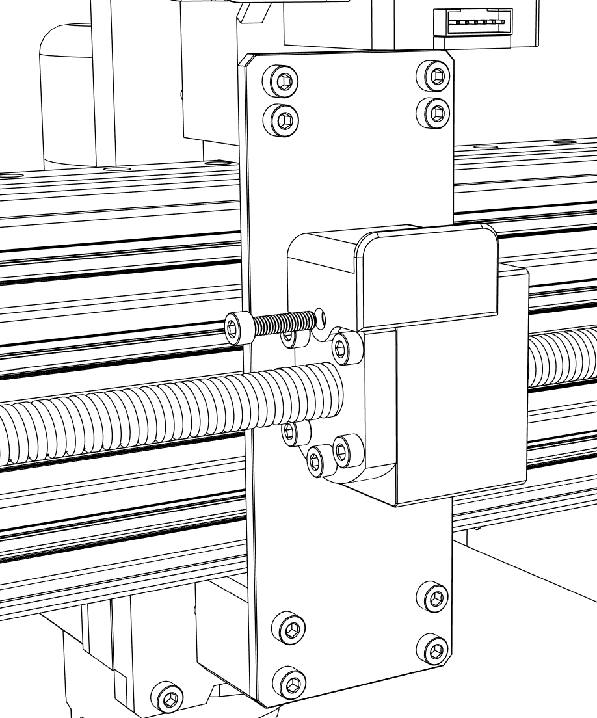

① Remove one screw holding the ball screw nut and install **X Axis cable chain support** with the screw.

1 x X Axis cable chain support

## Cable chains

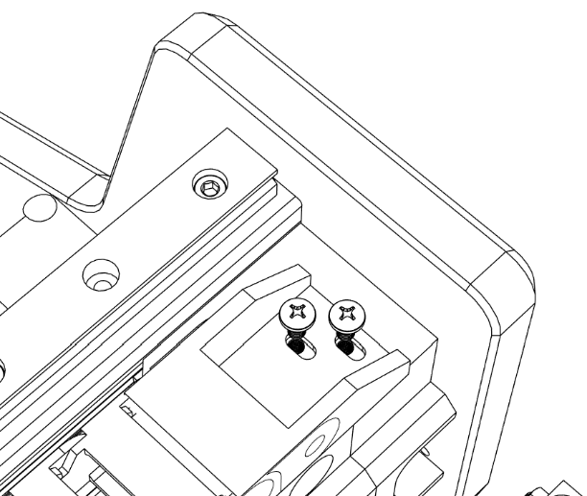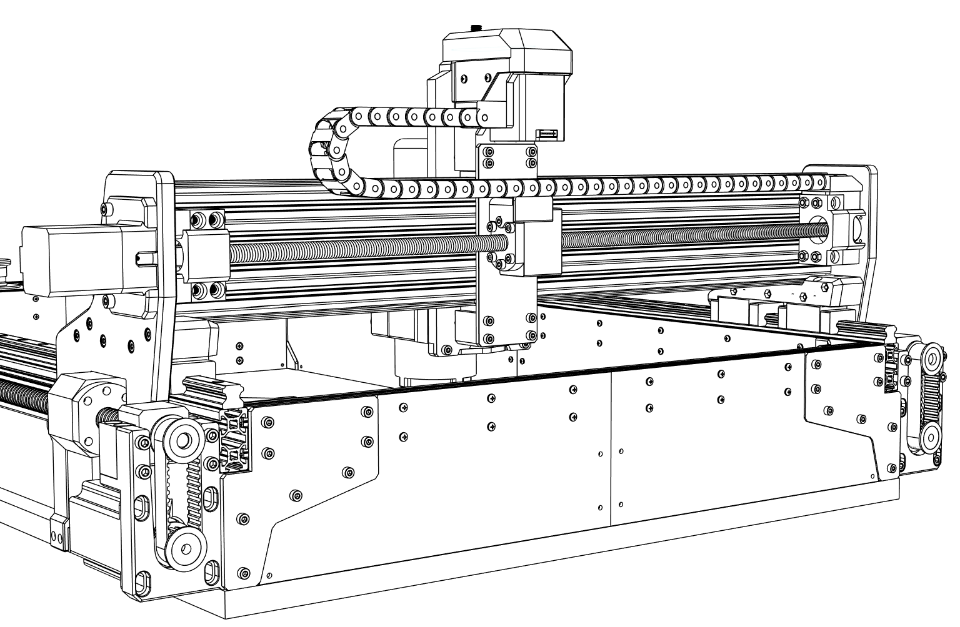

① Install **70 cm of cable chain** (±1 chain link) and secure it with M3x5 mm screw on one end.

1 x Cable chain (70 cm)

2 x M3x5 mm (Round head)

## Cable chains

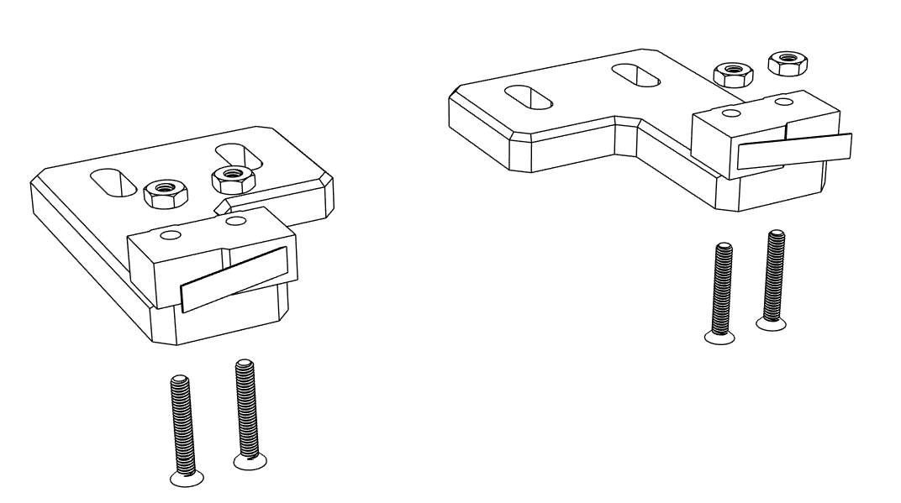

① Attach **KW11-3Z-B micro limit switches** to **Y Axis end stop mounts** with M2.5x16 mm screws and secure them with nuts.

② Make sure the limit switches are positioned as shown in the picture above.

1 x Y Axis end stop mount RIGHT

1 x Y Axis end stop mount LEFT

2 x Micro limit switch KW11-3Z-B

4 x M2.5x16 mm (Flat head)

4 x M2.5 Nut

## Limit switches

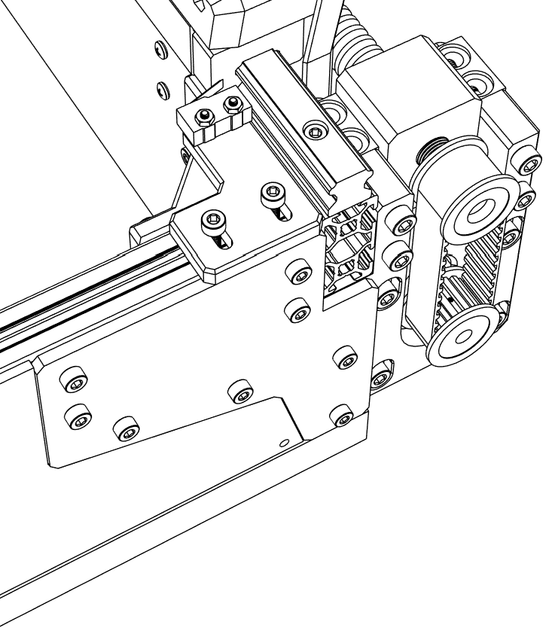

① Install the limit switches with M4x10 mm screws and M4 t-slot nuts on both sides of the machine.

② Limit switches can be later adjusted to enable auto-squaring.

4 x M4x10 mm (Socket head)

4 x M4 T-slot nut

## Limit switches

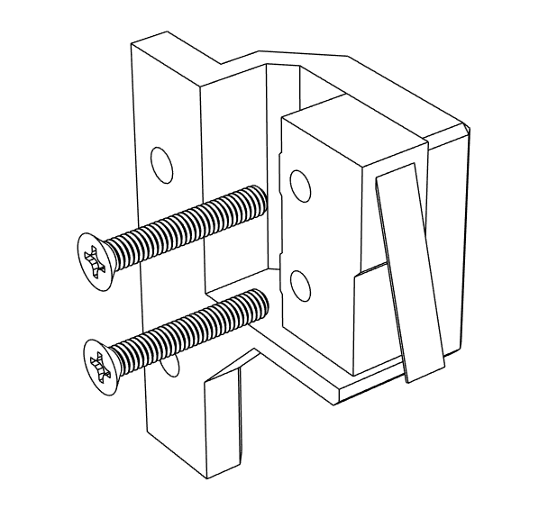

① Attach **KW11-3Z-B micro limit switch** to **X Axis end stop mount** with M2.5x16 mm screws.

1 x X Axis end stop mount

1 x Micro limit switch KW11-3Z-B

2 x M2.5x16 mm (Flat head)

## Limit switches

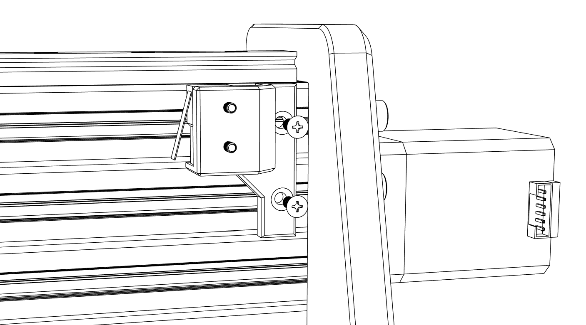

① Connect the X Axis end stop mount to the X axis aluminum profile with M3x8 mm screws and M3 t-slot nut.

② Make sure X axis can reach the limit switch to prevent collision when later homing the machine.

2 x M3x8 mm (Flat head)

2 x M3 T-slot nut

## Limit switches

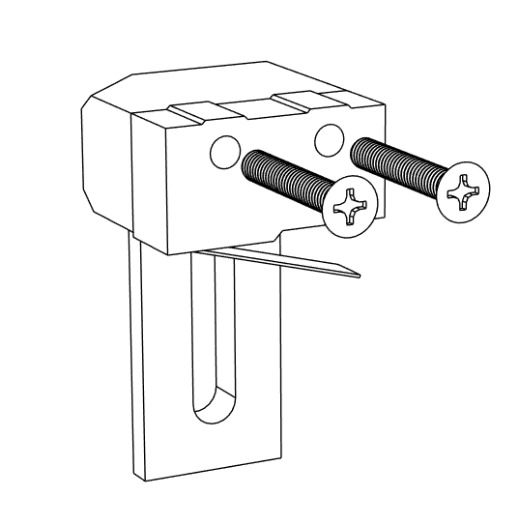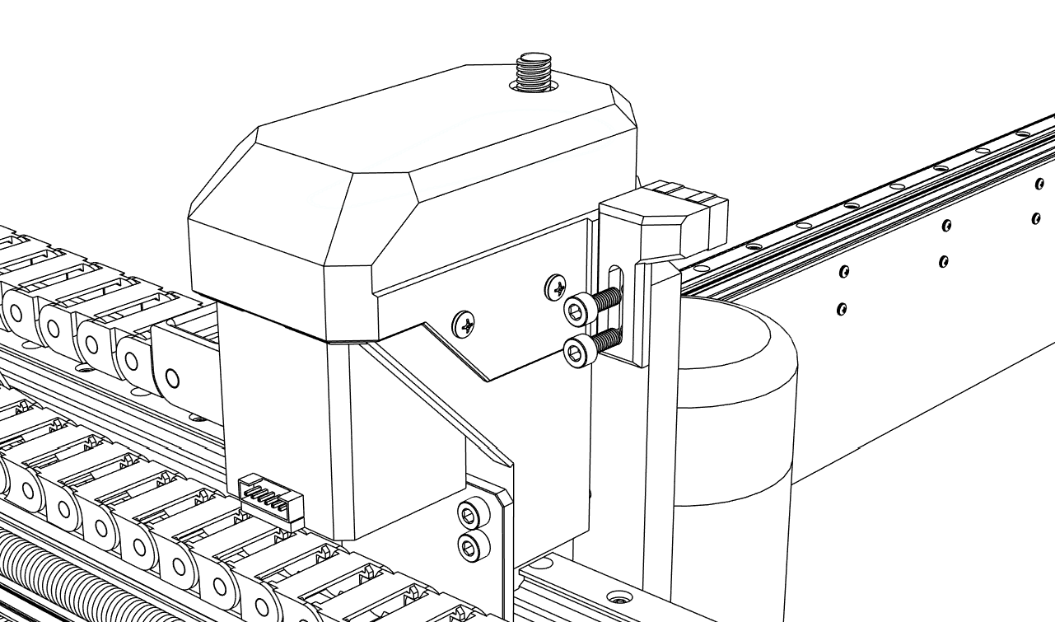

① Attach **KW11-3Z-B micro limit switch** to **Z Axis end stop mount** with M2.5x16 mm screws.

1 x Z Axis end stop mount

2 x M2.5x16 mm (Flat head)

## Limit switches

① Install the Z axis end stop mount to the Z axis plate with M4x10 mm screws.

② Once again make sure Z axis can reach the limit switch to prevent collision when later homing the machine.

2 x M4x10 mm (Socket head)

## Limit switches

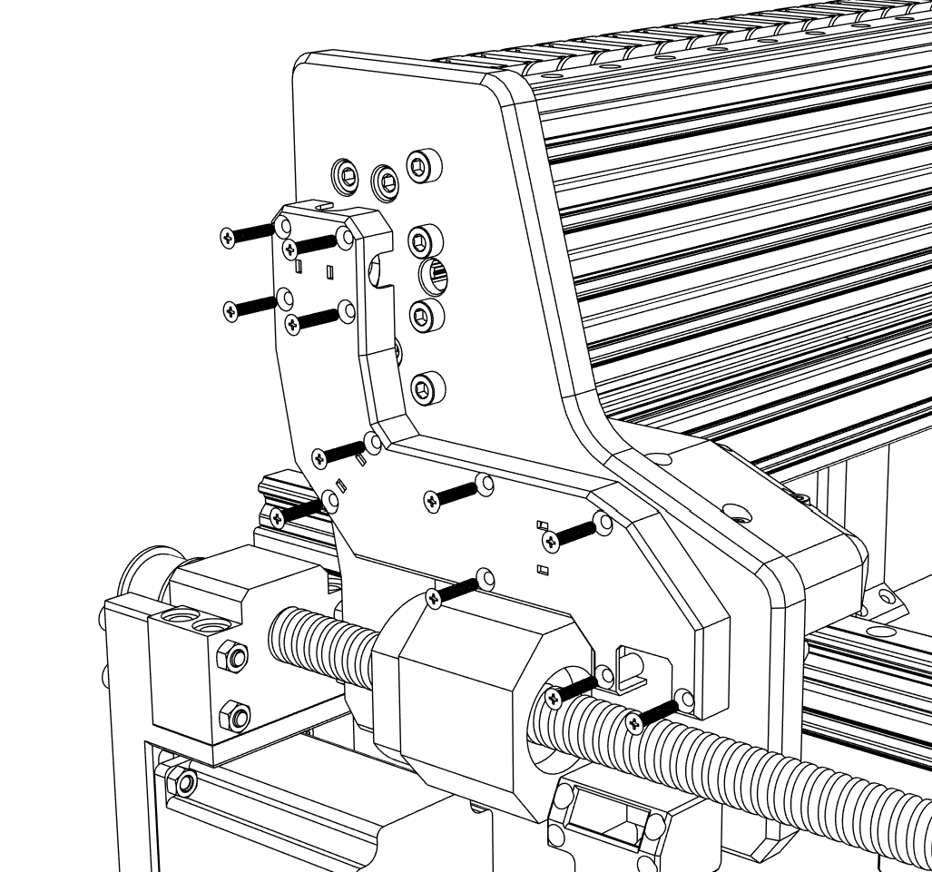

① After routing all the cables cover them with **Cable cover** secured with M3x16 mm screws.

② Spindle cable can be router outside the cover and secured with zip ties.

1 x Cable cover

11 x M3x16 mm (Flat head)

## Cable cover

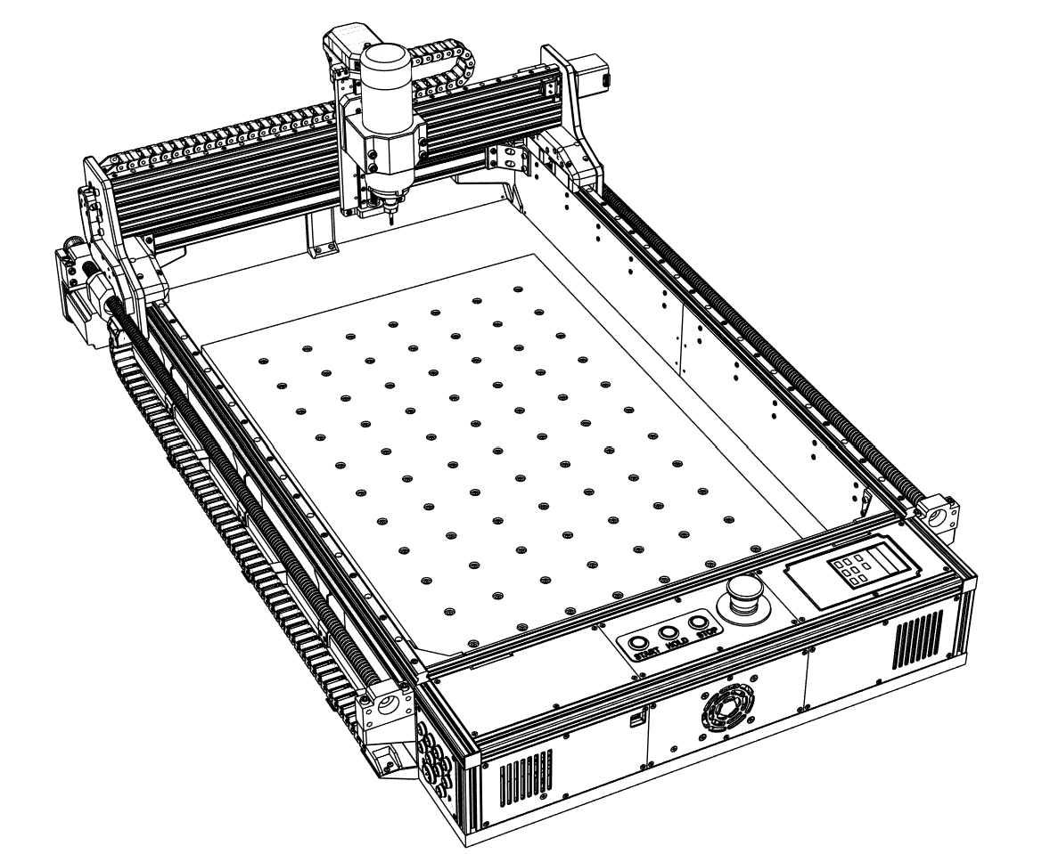

① Lastly secure the **MDF spoil board** with 4x20 mm wood screws.

② It is recommended to square and home the machine. Mark the spindle home position then move the spindle to the front and also mark its position. Spoil board should be then aligned with the markings and secured with screws.

③ Optionally holes for wood threaded inserts can be milled out for securing milled material.

1 x MDF Spoil board

8 x 4x20 mm wood screw (Flat head)

## Spoil board

Thank you for building the PCK CNC Router.

If you have encountered any problems during assembly or have any questions, please contact me at **PCKCNC@email.cz**